Year 1 Hindu Dharma
Year1 Key Question (to be used all year): What do people say about God?
Focus Question (for this investigation): What do Hindus believe about God?

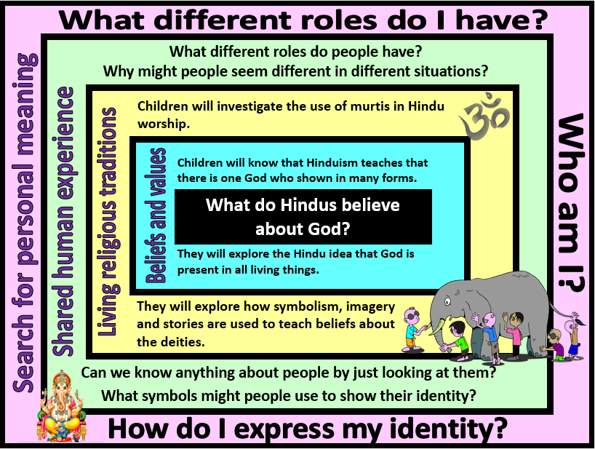
Focus Question: What do Hindus believe about God?
This unit gives children the opportunity to explore the Hindu concept of one God (Brahman) who can be understood and visualised in many forms. This unit should build on their prior learning about the use of symbolism to express religious beliefs. Children should be able to talk about how images of the deities in Hinduism are a visual representation of beliefs about God.
Children should also have opportunities to think about the complexity of identity and how people may be seen in different ways according to their role and relationship. There will be opportunities for children to develop self-awareness of their own identity and roles.
Field of Enquiry | Possible Teaching Ideas
Shared Human Experience  1 | - Teacher could talk about the different roles they have and the way that they are seen/named in each role (Mr/Miss/Mrs ___, mum, dad, brother, sister, son, daughter, friend, colleague, neighbour etc.)  - Explore the different roles that a person may have – and the different ways that a person might look in these different roles (eg. a police officer/nurse/fire-fighter in and out of uniform). Why might some roles include special clothing or visual ways of showing people what the person’s role is?
Beliefs and Values  2 | - Read the blind men and the elephant story – talk about why the blind men all had a different understanding of the elephant.  - Explain that this story helps us to understand what Hinduism teaches about God. Hinduism teaches that there is one God, but that people might understand God in many ways.  - Look at an image of the three deities of the Trimurti (Shiva, Vishnu and Brahma). Ask children to identify the similarities and differences between the three. Discuss the symbolism of the objects they carry/wear and how these link to their particular role within the Trimurti.
Living Religious Traditions  3 | - Investigate the use of murti in Hindu worship. Show children a murti of Lakshmi and/or Ganesh and ask them to work out why a Hindu might choose to worship these particular deities.  - Look at images of Hindu shrines – explain that these are used as a way of showing respect to all of the different understandings of God. Each aspect is worshipped and thanked for its own particular role.
Search for Personal Meaning  4 | - Talk about the different roles they have and the different ways that they might look or be called by different people.  - List all the skills and qualities that make them who they are – try to express these through an image. Design an item of clothing that they could wear to express all these different aspects of themselves.

Y1 Learning - children will:
- know that Hindus believe in one God in many forms  - know that Hindus believe that God is present in all living things  - suggest what Hindus might learn about God from the story of the blind men and the elephant | - talk about how and why Hindus might use statues and images (murtis) in their worship  - suggest symbolic meanings expressed in the images | - talk about the different ways that people can be seen and described  - consider how people might have multiple roles | - reflect on how others might see them  - talk about the different roles that they might have (friend, child, brother/sister etc.)
Beliefs and values | Living religious traditions | Shared human experience | Search for personal meaning

