Year 2 Christianity - God
Year 2 Key Question (to be used all year): How do we respond to the things that really matter?
Focus Question (for this investigation): Does how we treat the world matter?
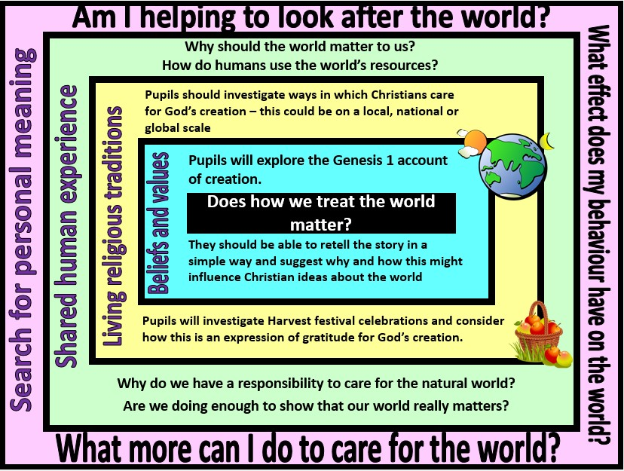

Focus Question: Does how we treat the world matter?
In this unit, pupils will look at Christian beliefs about God as creator and sustainer, and consider how these beliefs might influence Christian attitudes towards the planet. They should be able to retell the creation account in Genesis 1. Discussions might extend thinking by considering different ways that this story might be interpreted (as literal truth or as a myth containing religious messages). They will explore how Christians might express their beliefs and values through acts of stewardship and/or through harvest festivities.
Pupils should also discuss their own ideas and values in regards to the importance of caring for the planet. They should consider this as a human value, not just a religious one. This is an opportunity to discuss their own concerns about environmental issues and what they can do to make a difference.
Field of Enquiry | Possible Teaching Ideas
Shared Human Experience  1 | - Look at images of good and bad aspects of our world. Talk about how human activity can be both good and bad for the planet  - Look at images of natural beauty – discuss how the world can be a source of awe and wonder  - Discuss why the world should matter to all humans  - Raise questions about human behaviour – why don’t people focus more on caring for the world. Why do some people not seem to care?

Beliefs and Values 2 | - Listen to a children’s version of Genesis 1 eg. http://www.dltk- bible.com/genesis/chapter1-cv.htm or https://www.youtube.com/watch?v=yZ1Fd_SPC18  - Create a class frieze of pictures retelling the creation story  - In response to the story, talk about why Christians might believe that they should look after the world  - Look at the words of Christian hymns that might be sung at Harvest (eg. ‘All Things Bright and Beautiful’). Identify the beliefs and values contained in these words.
Living Religious Traditions  3 | - Find out about Christian groups that work to conserve the world’s resources and protect the environment. These could be linked to a local church or an organisation such as CAFOD, Christian Aid or A Rocha https://globaldimension.org.uk/resource/cafod-climate-environment- resources-primary/  - Look at pictures of crops being harvested. Talk about what has happened in order to make the crops grow and become something that is good to eat. Talk about why people are grateful for food and ways in which people might show their gratitude. Explore Harvest as a time when Christians thank God for all the good things in creation and try to share the good aspects of creation (especially food) with others.
Search for Personal Meaning  4 | - Talk about their own hopes and concerns for the natural world. Discuss how individual actions can make a difference (eg. reduce, reuse, recycle)  - Create a class pledge of things they will do to show that the world matters to them  - Create a collage of images of the good aspects of creation, with words to describe feelings of gratitude, awe and wonder

Y2 Learning - children will:
* retell (simply) the Genesis | * suggest ways that | * identify ways in which | * reflect on their own use of
1 story of creation | Christians might express | humans use (and abuse) the | the world’s resources
* suggest why Christians | their concern for the natural | natural world | * ask questions about what
might think it is important to | world | * about why our planet | they can do to show that
look after the world | * describe how and why | should matter to all humans | they care about the world
 | Christians might thank God | – and how this should
 | for creation at Harvest | influence our behaviour
 | festivals
Beliefs and values | Living religious traditions | Shared human experience | Search for personal meaning

