Year 4 Christianity (Jesus)
Year 4 Key Question (to be used all year): How should we live our lives?
Focus Question (for this investigation): Is sacrifice an important part of religious life?

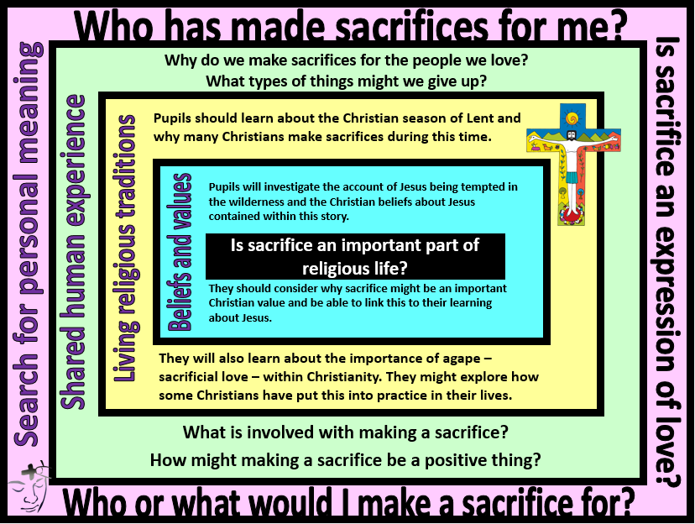
Focus Question: Is sacrifice an important part of religious life?
This unit investigates the person of Jesus through the concept of sacrifice. This links to prior learning about the principle of Zakat in Islam and also what it means to be a follower of Jesus by exploring how Christians might try to follow the example of Jesus through charity and personal sacrifice. It enables pupils to consider how Jesus’ sacrifices have provided a model for other Christians to mirror by showing agapé (selfless love for others). They will have opportunities to reflect on their own values and on what influences their choices.
Field of Enquiry | Possible Teaching Ideas
Shared Human Experience  1 | - Bring in some chocolate or sweets and place in the classroom. Explain that they are your favourite and you are tempted to eat them. Have another adult come into the room and say that they are very hungry and need to eat something. Ask the pupils- should I give them my sweets?  - Create semantic maps for the words temptation and sacrifice.  - Give pupils scenarios where a sacrifice is needed to resolve a problem. Make some personal e.g. for a family member, whilst others are to help someone they do not know or have not even met. Who would they be willing to make a sacrifice for? What would they have to give up?
Beliefs and Values  2 | - Watch the story of Jesus in the wilderness https://www.youtube.com/watch?v=P-6a25Yo2wE . What do the pupils think is happening? How was Jesus tempted in the story?  - What does the story of Jesus in the wilderness teach Christians about Jesus? Create a booklet with a different idea on each page.  - Provide screenshots from the clip. Children write the story to go with the images and explain the sacrifices that Jesus made. (This could be used as an assessment task for the unit.)  - Discuss why the pupils think that sacrifice is an important Christian value.  - This could be further linked with Easter as part of collective worship, for example by reflecting on the sacrifices that Jesus made in the Easter story and the Christian belief that this sacrifice saved them by bringing them closer to God
Living Religious Traditions  3 | - Explain what is meant by sacrificial love- agapé. Use RE Definitions app or see https://kids.britannica.com/students/article/agape/604729 for a definition. Discuss how this would affect the way in which a Christian behaves towards others?  - Learn about the life of Oscar Romero https://cafod.org.uk/Education/Primary-teaching-resources/Romero . Create a storyboard of key events from his life, showing how he followed the example of Jesus’ sacrificial live or ask pupils to design their own Romero cross with a written explanation of their work.  - Explain that Lent is the period leading up to Easter. It lasts for forty days and forty nights to mirror the time that Jesus spent in the wilderness. At this time, Christians prepare for Easter by trying to be more like Jesus. They often choose to give something up to test their own self-discipline and find out if they can resist temptation like Jesus did.  - Show statements from three children:  - ‘I have decided to give up buying clothes for Lent. I will give the money I save to charity.’  - ‘I am giving up my computer/tablet for Lent. This will mean I have more time to spend with my family.’  - ‘I have decided to give up sweets and cake this Lent. This helps me to remember children in other countries who don’t have enough food.’  Ask pupils to discuss who they think made the biggest sacrifice for Lent? Why?  Why might a Christian say that making a real sacrifice is important during Lent? (This could be an alternative  opportunity for assessment.)
Search for Personal Meaning  4 | - Organise a collection for a local food bank or charity. Pupils could create advertising posters for the collection that explain why giving up some food or money would be an expression of concern and love for others.  - Ask pupils about who they are willing to make sacrifices for. They could present these on jigsaw pieces to create a visual image of promises linked to the unit and the values of charity, compassion, respect for all etc.

Y4 Learning - pupils will:
- retell the story of Jesus in the wilderness  - identify Christian beliefs about Jesus reflected in this story  - suggest why sacrifice might be an important Christian value (linked to beliefs and teachings about Jesus) | - describe what a Christian might do during Lent and why  - explain what is meant by sacrificial love – agapé – and give examples of how Christians might do this  - Discuss Christians who have been examples of sacrificial love (eg. Oscar Romero) and how they were motivated by their faith | - consider differing attitudes and responses to the concept of sacrifice (both positive and negative)  - discuss why many people are willing to make sacrifices for the people they love  - discuss why some people may be willing to make a sacrifice for someone they don’t even know | - give examples of acts of sacrifice that have been done by or for them  - discuss who or what they would be prepared to make sacrifices for  - consider the value of sacrifice – as an expression of love and commitment
Beliefs and values | Living religious traditions | Shared human experience | Search for personal meaning

