Year 5 Christianity - God
Year 5 Key Question (to be used all year): Where can we find guidance about how to live our lives?
Focus Question (for this investigation): Why is it sometimes difficult to do the right thing?

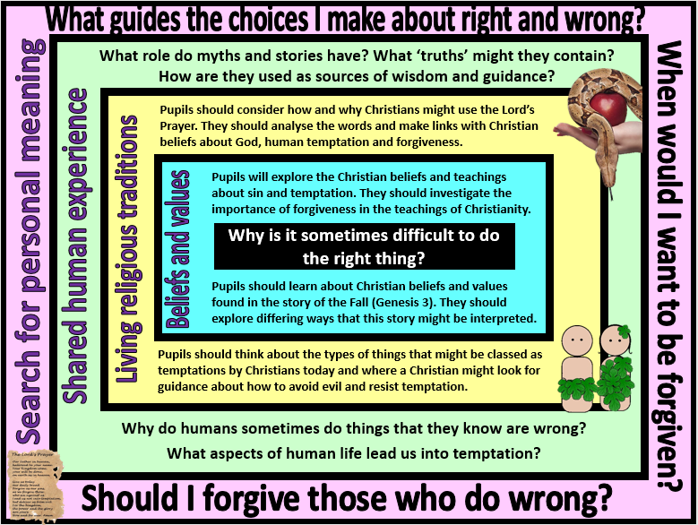
Focus Question: Why is it sometimes difficult to do the right thing?
This unit enables pupils to explore Christian beliefs and teachings about sin and temptation and introduce core Christian concepts such as The Fall, Original Sin, Free Will, forgiveness and reconciliation. Pupils should be encouraged to make links with prior learning about the creation story in Genesis 1 (particularly the point that God made the world ‘and saw that it was good’) and with their knowledge of baptism. They should have the opportunity to analyse and ask questions about the story found in Genesis 3, not simply retell it. Pupils should deepen their understanding of how and why Christians use the Bible by exploring different Christian interpretations of the text – literal and metaphorical – and how this might impact on a believer’s attitude towards sin and temptation in the world today.
Pupils should investigate the importance of forgiveness within the Christian faith and the way this might be put into action by both individuals and communities. They should be able to make links with teachings found in the Lord’s Prayer and other aspects of Christian worship such as prayers of penance, confession and reconciliation.
Pupils should reflect on things that might be seen as ‘temptations’ in modern life. They should be able to consider the role of greed and selfishness in leading people astray from doing the right thing – and ask questions about why we/they do things that we/they know are wrong. They should also be able to talk about their own views about the role of forgiveness: Why might it be important? Should we always forgive? Is it important to say sorry if you want to be forgiven? Why might it sometimes be difficult to forgive?

Field of Enquiry | Possible Teaching Ideas
Shared Human Experience  1 | - Discuss how stories might contain important truths and messages for people to learn from. Aesop’s Fables could be used as an example http://www.storyit.com/Classics/Stories/aesop.htm and pupils could talk about what life lessons they have learnt from books that they have enjoyed.  - If you have used ‘The boy who cried wolf’ this could be followed with a discussion about why the boy did something that he knew was wrong – and the eventual consequences that he faced. Pupils could then discuss other examples of when people deliberately do things that they know are wrong and the reasons for this.
Beliefs and Values  2 | - Re-cap the Genesis account of creation. Discuss the phrase ‘God saw that it was good’ – what do pupils think a good world would be like?  - Read the story of the Fall in Genesis 3 https://www.biblegateway.com/passage/?search=Genesis+3&version=ICB  - ‘Hot-seat’ two pupils in the role of Adam and Eve – rest of class to ask questions to explore why they disobeyed God and how they feel about the consequences of their actions.  - Discuss the different ways that the story could be understood by Christians – literal and metaphorical. If the story is metaphorical, who/what might each aspect of the story represent? If the story is believed literally, then what might Christians believe about the cause of sin and temptation in the world today  - Read the Parable of the Lost Son. Compare the God portrayed in Genesis 3 with the forgiving father in this parable. Discuss Christian beliefs about the importance of forgiveness (the Lost Son is sorry and returns home to seek forgiveness, there is no suggestion in Genesis 3 that Adam and Eve are sorry).
Living Religious Traditions  3 | - Look at the Lord’s Prayer, in particular the lines “forgive us our sins, as we forgive them those who sin against us. And lead us not into temptation, but deliver us from evil.” How do these words reflect Christian beliefs about sin, temptation and forgiveness?  - Come up with a list of things that Christians might describe as temptations in the modern world – how and why might a Christian try to avoid these aspects of life? It might be helpful to look at sources of guidance such as the Ten Commandments and consider if these rules are still helpful for Christians today when trying to avoid evil and temptation.  - Compare the ideas and practices of Catholic and Protestant Churches in regards to confession and prayers of penance. This would be an opportunity to invite in a priest/minister to answer any questions.
Search for Personal Meaning  4 | - Share their own ideas about moral guidance – how do they know the difference between right and wrong? How easy or difficult is it to always do the right thing? Who or what might be a good source of wisdom and guidance when they are tempted or when it is difficult to know what the right choice is.  - Discuss why some things might be seen as moral absolutes (eg. murder), whereas others might sometimes be less clear (eg. a parent stealing to feed a starving child). Are there some moral values or truths that always hold, no matter the situation? Why might different people sometimes have different views about right and wrong? This would work well as a P4C lesson.

Y5 Learning - children will:
* describe Christian beliefs about sin and forgiveness  * describe and explain the teaching from Genesis 3 – of how Adam and Eve disobeyed God  * suggest different ways that this story might be understood by Christians | * describe and explain how and why Christians might use the Lord’s Prayer  * analyse and interpret the Lord’s Prayer – and what guidance it provides for Christians  * suggest things that might lead Christians into temptation in the modern world – and how and why they might try to resist these temptations | *consider the different ways that myth and stories are and used  * explain how a ‘truth’ might be contained within a story | * consider how they decide what is ‘true’ – and how there might be different types of truth  * discuss and debate things that they consider to be true that others might disagree with
Beliefs and values | Living religious traditions | Shared human experience | Search for personal meaning

