Year 5 Judaism
Year 5 Key Question (to be used all year): Where can we find guidance about how to live our lives?
Focus Question (for this investigation): Do people need laws to guide them?

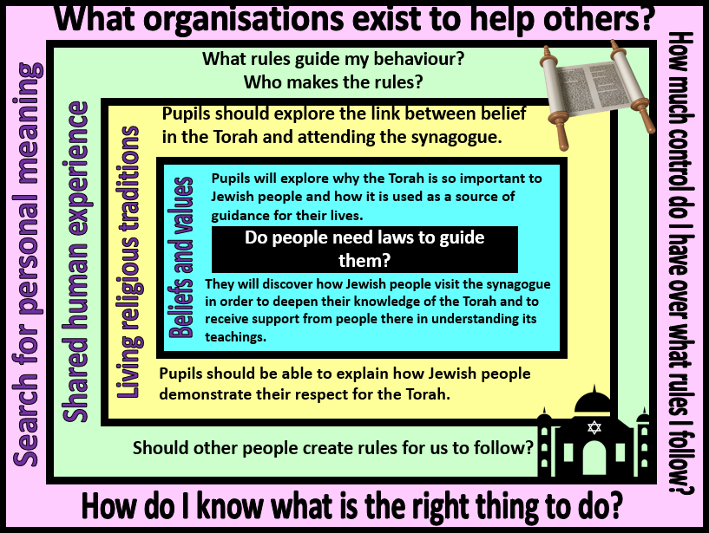
Focus Question: Why is it sometimes difficult to do the right thing?
This unit enables pupils to explore the importance of the Torah to Jewish people as a guide to life and faith. This unit has links with the Year 2 unit ‘What aspects of life really matter?’ and pupils will have opportunities for revisiting prior learning on how the Torah was given to Moses. Pupils will learn that Jewish people attend the synagogue in order to find out more about how to live their lives and to seek guidance from religious leaders. They will explore how the Torah is respected and honoured through Jewish worship and the way that it is used and handled at the synagogue. Pupils will then have time to reflect upon how they personally make decisions and who or what can have influence over this.
Field of Enquiry | Possible Teaching Ideas
Shared Human Experience  1 | - Give pupils sticky notes or slips of paper on which to write down three rules about their behaviour that they have to follow. Encourage them to think about within school and at home.  - Identify who makes these rules. Where have they found out about them?  - One of our human rights is freedom of expression. Discuss if the pupils think it is fair that they have to follow rules that they have not made themselves? What if we want to do something that is against the rules?
Beliefs and Values  2 | - Show ‘The Jewish Story of Moses’ from Religions of the World series. https://www.youtube.com/watch?v=RdSQT7DS1lI&list=PLcvEcrsF_9zIQm-KPGujuZkNRk_jTcehV&index=9&t=0s (This programme is aimed at KS1 and pupils may have seen it before – this aspect of the lesson is to recap prior learning).  - It is believed that the Torah was given to Moses when God made a covenant with the Jewish people after they had been freed from slavery in Egypt. The Torah was given to them to be a foundation of how to live as people of God.  - Stories from the Torah, eg Abraham, Moses all have lessons for Jews and help guide them and live their lives, eg http://www.bbc.co.uk/education/clips/zjkq6sg.  - The book contains 613 rules that teach people how to live. Explore some of these by watching https://www.bbc.co.uk/bitesize/clips/z8r87ty and https://www.youtube.com/watch?v=3QZ792rjcVE&list=PLcvEcrsF_9zL_rMIPzjyuhf7-VuPVq4yI&index=41&t=0s .Pupils could then research rules to do with family life and create posters to demonstrate their knowledge.  - One of the rules is that Jewish people should learn about and study the Torah throughout their lives. They do this by attending the synagogue where the Torah is read aloud and the Rabbi (literally ‘teacher’) is there to offer insight and guidance into its teaching.
Living Religious Traditions  3 | - Attending the synagogue gives Jewish people time to focus on God and for the Rabbi and community to pass on religious and moral teachings to the people.  - Watch https://www.bbc.co.uk/bitesize/clips/z834wmn and ask pupils to identify what the Bimah, Ark and yad are, or do research into them. Pupils could write a recount of a visit to a synagogue from the point of view of a Jewish person describing their use.  - Identify ways in which Jewish people show respect for the Torah. Pupils could read and discuss these with a partner or group before ranking them in order of importance and explaining the reasons for their choices. An activity sheet for has been produced by RE Today and is available on page 30 of the Inspiring RE ‘Jewish People’ book https://www.retoday.org.uk/school-support/publications/samples/retoday-magazine/  - Learning could be further enhanced by visiting a synagogue such as https://shulbythesea.co.uk/school-group-visits/ or by using the ‘Email a believer’ resource at http://pof.reonline.org.uk/  - A possible assessment activity for this unit would be to provide pupils with images of Jewish use of the Torah and worship at the synagogue. The pupils should explain what each is, why it is important and how it is used in worship.
Search for Personal Meaning  4 | - When we have decisions or dilemmas who or where can I turn to for guidance?  - Discuss the amount of control that pupils have over their decisions. Would they like more control? Carry out Conscience Alley drama activity to explore any identified areas.

Y5 Learning - pupils will:
- Make links between beliefs and sacred texts (in this case, the Torah), including how and why religious sources are used to teach and guide believers  - Explain the impact of Jewish beliefs and values – including reasons for diversity | - Explain differing forms of expression within the context of Jewish worship.  - Describe diversity of religious practices and lifestyle within t  - Interpret the deeper meaning of symbolism – contained in stories, images and actions | - Explain (with appropriate examples) where people might seek wisdom and guidance  - Consider the role of rules and guidance in uniting communities | - Discuss and debate the sources of guidance available to them  - Consider the value of differing sources of guidance
Beliefs and values | Living religious traditions | Shared human experience | Search for personal meaning

