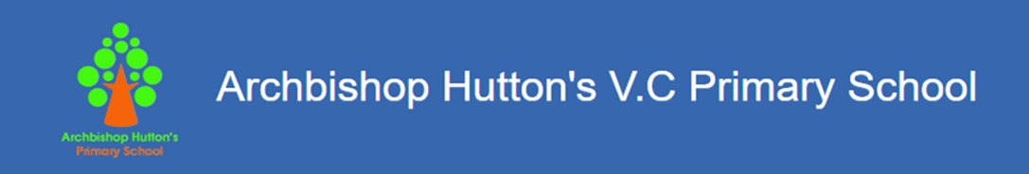

MATHEMATICS SEQUENCE OF LEARNING and CALCULATIONS POLICY

This document explains how we sequence the learning of Mathematics and how we teach the different forms of calculation at Archbishop Hutton’s Primary School.
The calculations policy is organised by year groups and designed to ensure progression for each operation in order to ensure smooth transition across the school. Mathematical understanding is developed through use of representations that are first of all concrete (e.g. base ten, apparatus), then pictorial (e.g. array, place value counters) to then facilitate abstract working (e.g. column addition, long multiplication).
It is important that conceptual understanding, supported by the use of representation, is secure for procedures and if at any point a pupil is struggling with a procedure, they should revert to concrete and/or pictorial resources and representations to solidify understanding or revisit the previous year’s strategy.
Our calculations policy is designed to help teachers and staff members at our school ensure that calculation is taught consistently across the school and to aid them in helping children who may need extra support or challenges. It also allows teachers to close gaps in learning by clearly demonstrating the methods that have been taught previously.
The calculations policy is also designed to help parents, carers and other family members support children’s learning by letting them know the expectations for their child’s year group and by providing an explanation of the methods used in our school.

What is our Intent for Maths

Mathematics teaches us how to make sense of the world around us. With a well developed ability to calculate, to reason and to solve problems, children are enabled to understand and appreciate relationships and pattern in both number and space in their everyday lives. Mathematics is integral to all aspects of life and with this in mind we endeavour to ensure that children develop a healthy and enthusiastic attitude towards mathematics that will stay with them to encourage economic wellbeing in later life.
Mathematical experiences help develop skills such as communication, generalising, evaluating and enquiry. At Archbishop’s Primary School, we recognise this importance and therefore provide our children with a wide range of mathematical experiences.

How is Maths organised from Reception to Year 6?
- What skills and knowledge do we teach?
- How have we sequenced learning?
- How do we ensure coverage of the National Curriculum?

Our Sequence of learning is centred around the basics each year – place value, addition, subtraction, multiplication and division.

Each class has a sequence of learning which organises the learning logically. All calculations are taught in line with the school calculations policy. This policy incorporates the Lancashire and White Rose Calculations policies.

Maths delivery makes use of the White Rose materials (as appropriate) and other materials chosen by the teacher. White Rose is used as a resource and jumping off point for learning but is not rigidly used as the only resource for learning.

In Reception the teacher baselines the children in the first two weeks and over the 1st half term introduces basic concepts such as number identification, counting objects, number bonds to five, shapes etc.

The Reception teacher uses regular activities (based around White Rose) and assessments to see where children are making progress and to encourage the children to use maths. Interventions are planned and delivered for those who need it and extends others through the use of 1:1 teaching and teacher observed continuous provision.

Throughout Reception year, there is a concerted effort to introduce and use the correct Maths vocabulary.
……………………………………………………………………………………………….

Key Stage 1 builds on the learning from Reception. Using the assessments from EYFS, the KS1 teacher groups accordingly and delivers the sequence of learning using appropriate materials and activities.

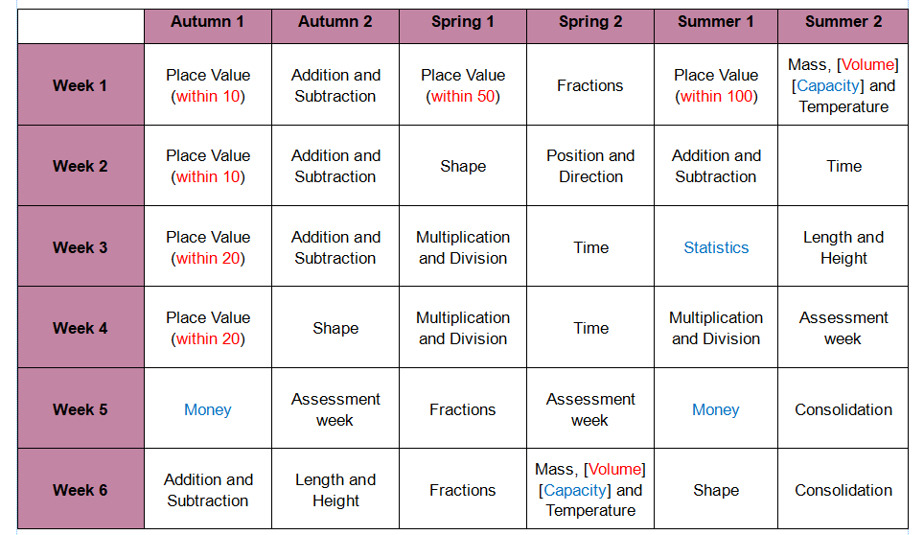

Throughout KS1 - through grouping and sharing small quantities, pupils begin to understand: multiplication and division; doubling numbers and quantities; and finding simple fractions of objects, numbers and quantities. They make connections between arrays, number patterns, and counting in twos, fives and tens.

Children have full access to manipulatives across all lessons.

Group input sessions are interactive and structured to introduce, explore and develop subject areas across the learning period. Teacher and TAs monitor the children’s independent work, encouraging exploration, experimentation and the mastering of techniques through a variety of hands-on tasks.

As the children develop through KS1 the work becomes more formal and concepts are embedded to ensure that children have a solid understanding.

All along the way, interventions are used to support learners, reinforce concepts and allow children opportunity to revise and practice previously learnt concepts (see information on interventions below)

Cross Curricular work such as Science, DT, Art, History and Geography provide opportunities to use Maths skills as a tool for learning. (EG) Measuring ingredients, time and lengths. Exploring shape and pattern. Ordering size, age, dates. Gathering data and presenting it in graphs and charts.
……………………………………………………………………………………………….

Lower Key Stage 2 builds on the learning from Reception and KS1. Using the assessments from KS1, the Y3 and 4 teacher groups accordingly and delivers the sequence of learning using appropriate materials and activities.

In our lower key stage 2 class – years 3 and 4 children develop valuable written and mental mathematics methods and do calculations correctly with increasingly large whole numbers. Children build their ability to solve a wide range of problems, including decimal place values and simple fractions.

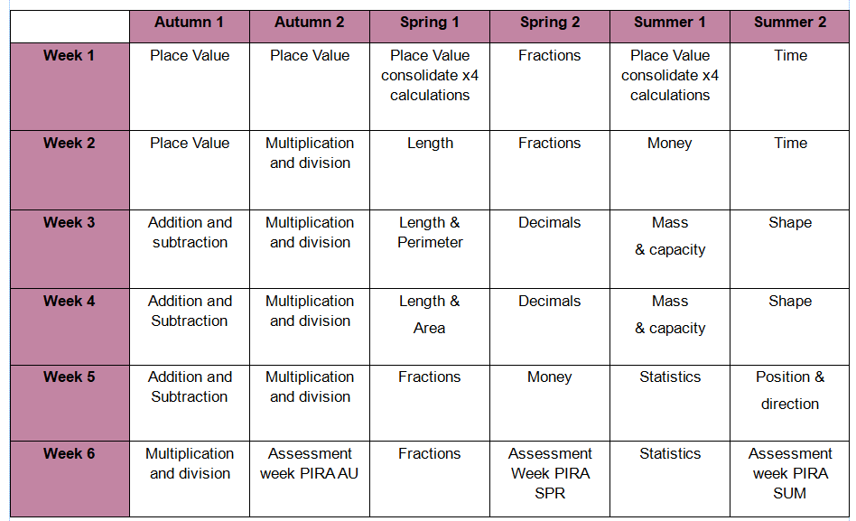

Our primary focus in lower key stage 2 is to make children increasingly fluent with the four operations and whole numbers, including the concept of place value and number facts. In years 3 and 4 children develop valuable written and mental mathematics methods and do calculations correctly with increasingly large whole numbers. Children build their ability to solve a wide range of problems, including decimal place values and simple fractions.
Children build mathematical reasoning so they can evaluate shapes with their properties, and correctly demonstrate the relationship between them. Children learn to use measuring instruments correctly and make connections between numbers and measures.

Before year 4 ends, children are expected to have memorised their 1 to 12 multiplication tables. Their work needs to demonstrate fluency and precision. Using their increasing knowledge of spelling and word reading, KS2 students must spell and read mathematical vocabulary with accuracy and confidence.

Many pupils – especially those with additional needs - might benefit from concrete, pictorial, abstract methods of teaching, so children have full access to manipulatives across all lessons.

Group input sessions are interactive and structured to introduce, explore and develop subject areas across the learning period.

Daily activities include Tough Ten, Times Tables apps and arithmetic based starters to revise and practice but to also assess progress.

Work in books takes the form of progressive activities from White Rose alongside other resources. Children in KS2 are encouraged to use their Maths books to work out solutions to the problems they are given, using taught calculations. The books should be workbooks with calculations, drawings and mistakes made evident as well as correct answers.

Teacher and TAs monitor the children’s independent work, encouraging exploration, experimentation and the mastering of techniques through a variety of hands-on tasks.

More confident pupils might be able to take on the curriculum without any additional scaffolding.

All along the way, interventions are used to support learners, reinforce concepts and allow children opportunity to revise and practice previously learnt concepts. (see below)

Cross Curricular work such as Science, DT, Art, History and Geography provide opportunities to use Maths skills as a tool for learning.
………………………………………………………………………………………………

Upper Key Stage 2 builds on the learning so far. Using the assessments from Y3 and 4, the teacher groups accordingly and delivers the sequence of learning using appropriate materials and activities.

The primary focus of teaching maths in our Upper Key Stage 2 class is to extend students' understanding of the place value and number system to include larger digits. At this level, students build connections between division and multiplication with percentages, decimals, ratios and fractions.
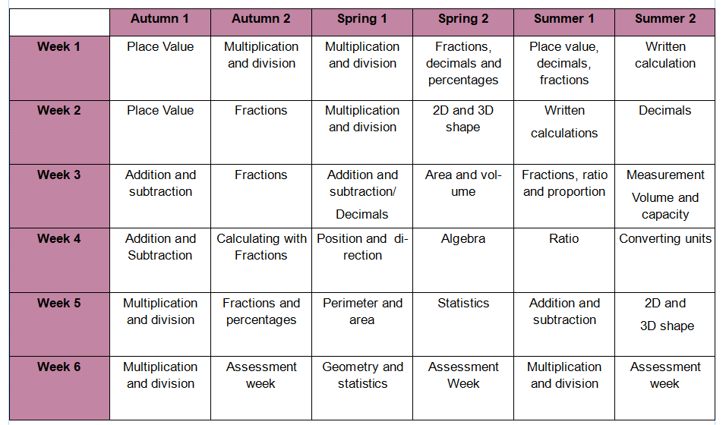

In UKS2, students build their skills of problem-solving using complex arithmetic and mental methods of calculation. When they are ready, and depending on their level of understanding, students are introduced to the concepts of algebra which to solve a variety of problems.

Teaching algebra and geometry extend and consolidate students' conceptual knowledge of numbers. The UKS2 teacher makes sure that the students categorise shapes with highly complex geometry and learn about position. They must know the vocabulary they need to define them.

By the end of Key Stage Two our students who are at age related expectations have gained fluency in written techniques for all of the four operations, including long division and multiplication, and in using decimals, fractions, and percentages.

Daily activities include Tough Ten, Times Tables apps and arithmetic based starters to revise and practice but to also assess progress.

Work in books takes the form of progressive activities from White Rose alongside other resources. Children in KS2 are encouraged to use their Maths books to work out solutions to the problems they are given, using taught calculations. The books should be workbooks with calculations, drawings and mistakes made evident as well as correct answers.

Teacher and TAs monitor the children’s independent work, encouraging exploration, experimentation and the mastering of techniques through a variety of hands-on tasks.

More confident pupils might be able to take on the curriculum without any additional scaffolding. Learning will be extended using websites such as NRICH or Maths.com

All along the way, interventions are used to support learners, reinforce concepts and allow children opportunity to revise and practice previously learnt concepts. Groups are targeted for intervention to close gaps and ensure concepts are embedded and children are confident in Maths. (see below)

Cross Curricular work such as Science, DT, Art, History and Geography provide opportunities to use Maths skills as a tool for learning.

How do we assess maths from Reception to Year 6?
- Baselines carried out at start of Reception Year
- Regular (weekly or more) 1:1 assessment made by teacher – this then informs continuous provision but also immediate extra intervention
- Teachers use formative assessments to make daily judgements during lessons + when marking
- Teachers regularly use this to adapt groupings and lesson delivery
- Pupils complete formal and informal assessments – Daily Tough Ten activities, Flashback Four etc
- Use of White Rose Challenge questions to assess reasoning as well as arithmetic skills
- Termly assessments using end of unit White Rose assessments and Rising Stars PIRA tests. These test what children will have covered in that year group, but like SATS also cover knowledge up to that age group.
- Regular (half termly) moderation sessions held during teacher meetings. Target children are chosen and class books looked at. An area such as division may be chosen and staff look to see progression of skills and knowledge in line with NC and school calculation policy being used correctly.

How are SEND/PPG children supported/ planned for?
Our policy for adapting learning for SEND children are detailed in our School Curriculum plan
When we plan lessons:
We ensure tasks are effectively differentiated and ambitious in their outcomes for all students. Organise work for learners with SEN in smaller chunks with plenty of opportunities for revisiting and over learning, where appropriate. This might involve smaller follow-up tasks. These are adapted to make use of simpler formats, manipulatives, peer and adult support.
We use technology where appropriate to scaffold the learner. This may include equipment, apps, or specialist software which can effectively support SEN.
We deploy other adults in the classroom to effectively facilitate learning.
Teachers incorporate flexible grouping – do not always group children with similar SEN together; allow them to learn from their peers.
Teachers plan in the use of talk partners – this gives children with SEN access to peer support and the ability to rehearse their responses.

What does intervention look like across school?
How are gaps in learning filled? Who carries it out? How often does it happen?
Teachers plan interventions for children based on need. All teachers to produce a provision plan detailing the interventions that are taking place within the class. This is adapted regularly.
Interventions are flexible and alongside the basics – number bonds etc – specific interventions are put in place when a concept needs more work. Teachers plan these interventions. Inventions are allocated for a pre-agreed period of time, accompanied by measurable goals, and regularly evaluated. Teacher and TAs carry out interventions either in lessons or during afternoon sessions.
All learners have a statutory right to a broad and balanced curriculum, so we take care to ensure that those children with SEN are not consistently removed from the same lessons for interventions.

Archbishop Hutton’s Primary School Maths Calculations Progression Policy

Progression Towards a Written Method for Addition

In developing a written method for addition, it is important that children understand the concept of addition, in that it is:
- Combining two or more groups to give a total or sum
- Increasing an amount

They also need to understand and work with certain principles, i.e. that it is:
- the inverse of subtraction
- commutative i.e. 5 + 3 = 3 + 5
- associative i.e. 5 + 3 + 7 = 5 + (3 + 7)

The fact that it is commutative and associative means that calculations can be rearranged, e.g.
4 + 13 = 17 is the same as 13 + 4 = 17.

yr
Early Learning Goal:
Using quantities and objects, children add two single-digit numbers and count on to find the answer.

Children are encouraged to develop a mental picture of the number system in their heads to use for calculation. They should experience practical calculation opportunities using a wide variety of practical equipment, including small world play, role play, counters, cubes etc.

Counting all method
Children will begin to develop their ability to add by using practical equipment to count out the correct amount for each number in the calculation and then combine them to find the total. For example, when calculating 4 + 2, they are encouraged to count out four counters and count out two counters.

To find how many altogether, touch and drag them into a line one at a time whilst counting.

6
1
2
3
4
5

By touch counting and dragging in this way, it allows children to keep track of what they have already counted to ensure they don’t count the same item twice.
Counting on method
To support children in moving from a counting all strategy to one involving counting on, children should still have two groups of objects but one should be covered so that it cannot be counted. For example, when calculating 4 + 2, count out the two groups of counters as before.

then cover up the larger group with a cloth.

4

For most children, it is beneficial to place the digit card on top of the cloth to remind the children of the number of counters underneath. They can then start their count at 4, and touch count 5 and 6 in the same way as before, rather than having to count all of the counters separately as before.
Those who are ready may record their own calculations.

Y1
End of Year Objective:
Add one-digit and two-digit numbers to 20, including zero (using concrete objects and pictorial representations).

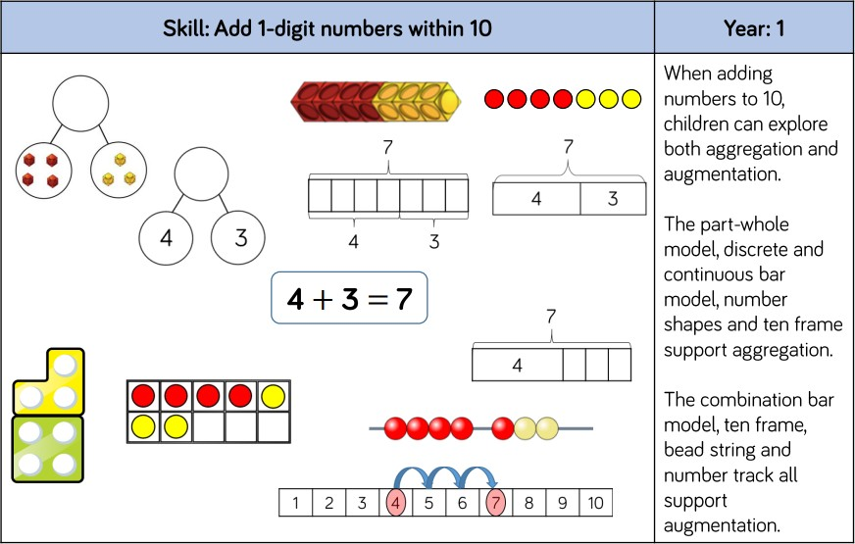

Children will continue to use practical equipment, combining groups of objects to find the total by counting all or counting on. Using their developing understanding of place value, they will move on to be able to use Base 10 equipment to make teens numbers using separate tens and ones.

For example, when adding 11 and 5, they can make the 11 using a ten rod and a one.

The ones can then be combined to aid with seeing the final total, e.g.

so 11 + 5 = 16. If possible, they should use two different colours of base 10 equipment so that the initial amounts can still be seen.

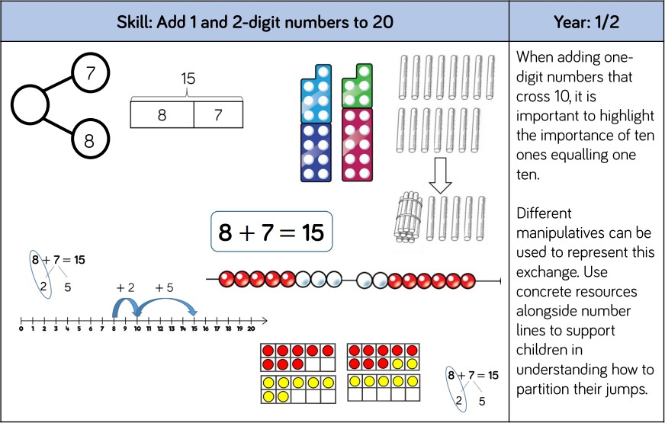

Y2
End of Year Objective:
Add numbers using concrete objects, pictorial representations, and mentally, including: a two-digit number and ones; a two-digit number and tens; two two-digit numbers; three one-digit numbers.

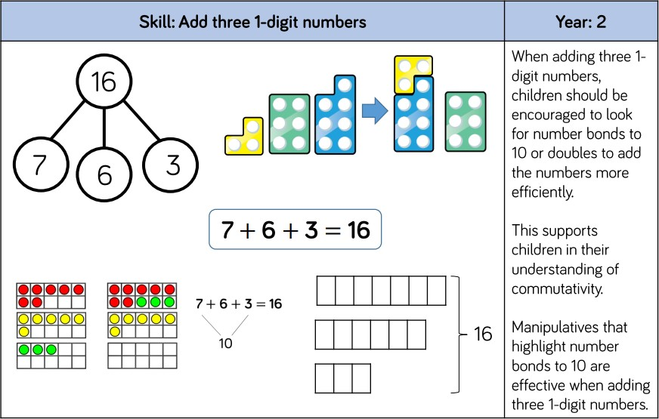



Children will continue to use the Base 10 equipment to support their calculations. For example, to calculate 32 + 21, they can make the individual amounts, counting the tens first and then count on the units.

53

When the ones total more than 10, children should be encouraged to exchange 10 units/ones for 1 ten. This is the start of children understanding ‘carrying’ in vertical addition. For example, when calculating
35 + 27, they can represent the amounts using Base 10 as shown:

Then, identifying the fact that there are enough units/ones to exchange for a ten, they can carry out this exchange:


To leave:

Children can also record the calculations using their own drawings of the Base 10 equipment (as slanted lines for the 10 rods and dots for the unit blocks).
e.g. 34 + 23 =

With exchange:
exchanged 10
e.g. 28 + 36 =

will become

so 28 + 36 = 64

It is important that children circle the remaining tens and units/ones after exchange to identify the amount remaining.
This method can also be used with adding three digit numbers, e.g. 122 + 217 using a square as the representation of 100.
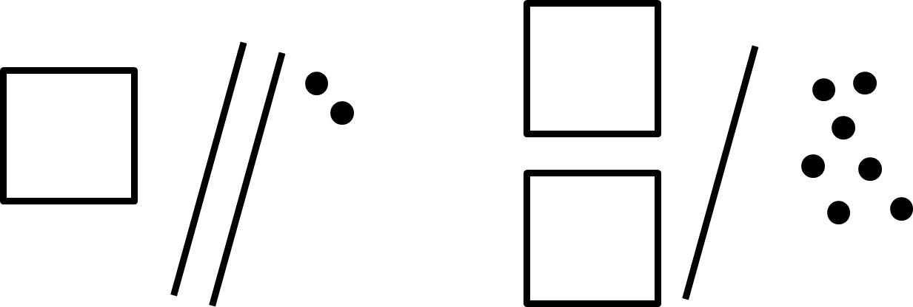

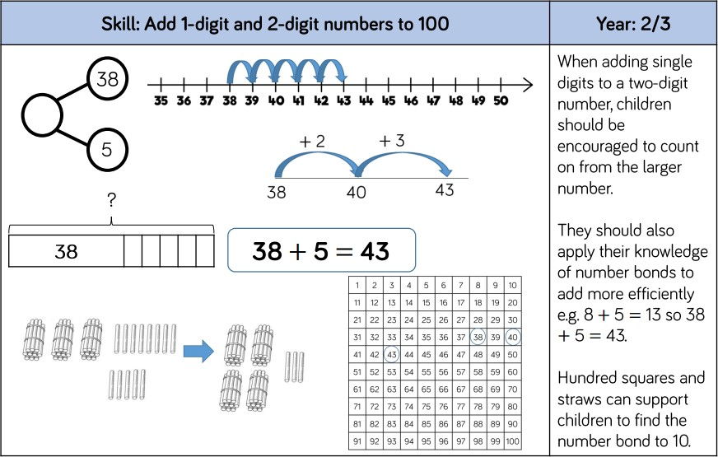

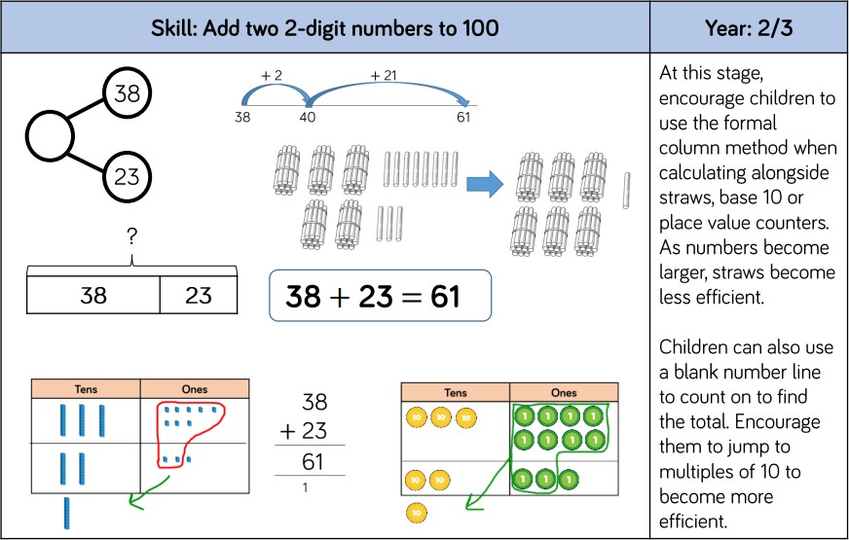

Y3
End of Year Objective:
Add numbers with up to three digits, using formal written method of columnar addition.*

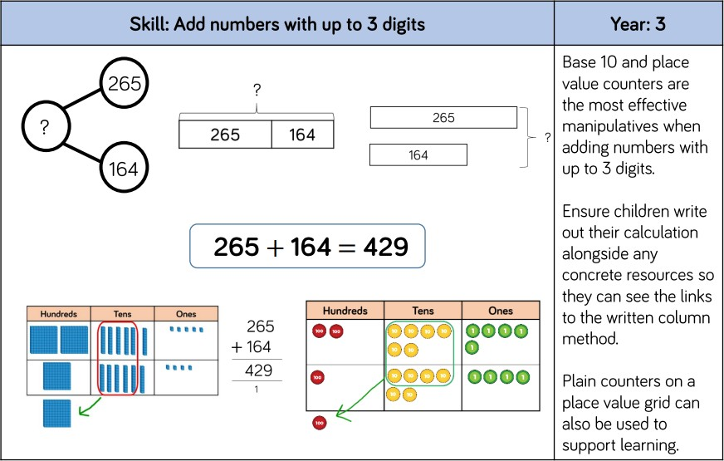

*Although the objective suggests that children should be using formal written methods, the National Curriculum document states “The programmes of study for mathematics are set out year-by-year for key stages 1 and 2. Schools are, however, only required to teach the relevant programme of study by the end of the key stage. Within each key stage, schools therefore have the flexibility to introduce content earlier or later than set out in the programme of study.” p4

It is more beneficial for children’s understanding to go through the expanded methods of calculation as steps of development towards a formal written method.

Children will build on their knowledge of using Base 10 equipment from Y2 and continue to use the idea of exchange.

Children should add the least significant digits first (i.e. start with the units/ones), and in an identical method to that from year 2, should identify whether there are greater than ten ones which can be exchanged for one ten.

They can use a place value grid to begin to set the calculation out vertically and to support their knowledge of exchange between columns (as in Step 1 in the diagram below).
e.g. 65 + 27

Step 1 Step 2
T U
T U

Remaining units

Exchanged ten

Children would exchange ten units/ones for a ten, placing the exchanged ten below the equals sign. Any remaining units/ones that cannot be exchanged for a ten move into the equals sign as they are the ones part of the answer (as in the diagram in Step 2 above).

If there are any tens that can be exchanged for a hundred, this can be done next. If not, the tens move into the equals sign as they are the tens part of the answer (as in the diagram in Step 3 below).

Step 3 Written method
T U
Step 1 Step 2 Step 3
 | T | U
 | 6 | 5
+ | 2 | 7
 |  | 2
 | 1

 | T | U
 | 6 | 5
+ | 2 | 7
 | 9 | 2
 | 1

 | T | U
 | 6 | 5
+ | 2 | 7

Children should utilise this practical method to link their understanding of exchange to how the column method is set out. Teachers should model the written method alongside this practical method initially. This should progress to children utilising the written and practical methods alongside each other and finally, and when they are ready, to children utilising just the written method.

By the end of year 3, children should also extend this method for three digit numbers.

Y4
End of Year Objective:
Add numbers with up to 4 digits and decimals with one decimal place using the formal written method of columnar addition where appropriate.

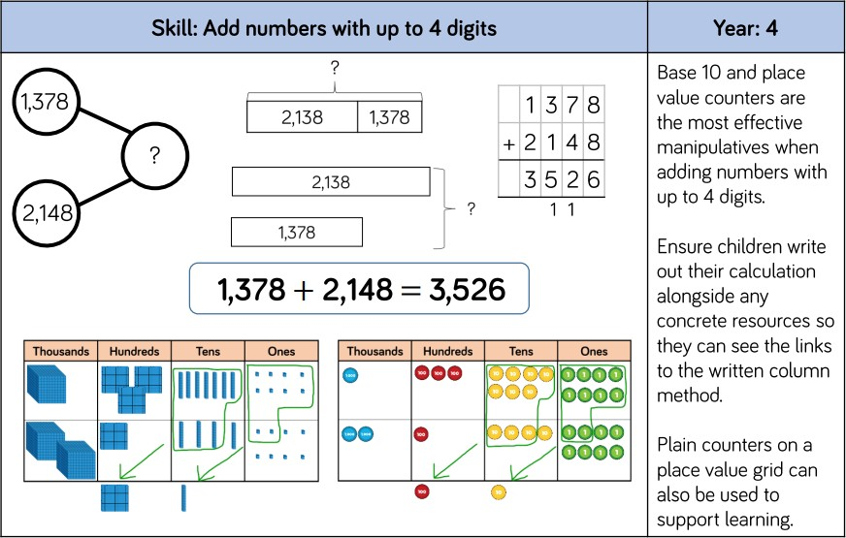

Children will move to year 4 using whichever method they were using as they transitioned from year 3.

Step 1
H T U
 | H | T | U
 | 3 | 6 | 5
+ | 2 | 4 | 7

Step 2
H T U
 | H | T | U
 | 3 | 6 | 5
+ | 2 | 4 | 7
 |  |  | 2
 |  | 1

Step 3
H T U
 | H | T | U
 | 3 | 6 | 5
+ | 2 | 4 | 7
 |  | 1 | 2
 | 1 | 1

Step 4
H T U
 | H | T | U
 | 3 | 6 | 5
+ | 2 | 4 | 7
 | 6 | 1 | 2
 | 1 | 1

By the end of year 4, children should be using the written method confidently and with understanding. They will also be adding:

- several numbers with different numbers of digits, understanding the place value;
- decimals with one decimal place, knowing that the decimal points line up under one another.

Y5
End of Year Objective:
Add whole numbers with more than 4 digits and decimals with two decimal places, including formal written methods (columnar addition).

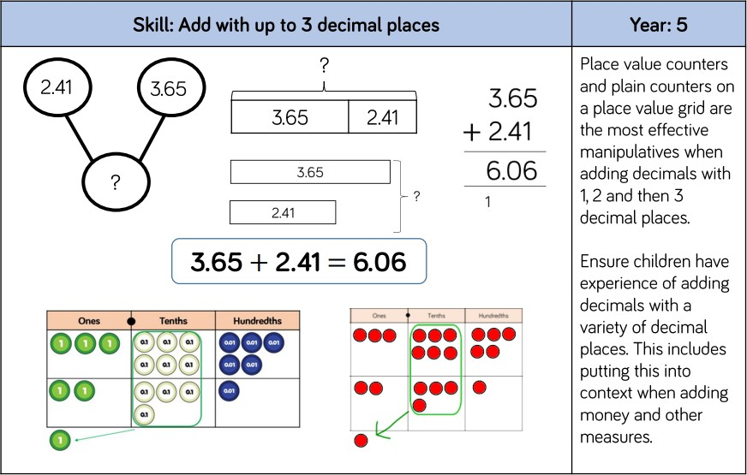

Children should continue to use the carrying method to solve calculations such as:

 | 3 | 3 | 6 | 4
+ |  | 2 | 4 | 7
 | 3 | 6 | 1 | 1
 |  | 1 | 1

 | 3 | 1 | 2 | 1
 |  |  | 3 | 7
+ |  | 1 | 4 | 8
 | 3 | 3 | 0 | 6
 |  | 1 | 1

 | 3 | . | 5 | 6
+ | 2 | . | 4 | 7
 | 6 | . | 0 | 3
 |  |  | 1

They will also be adding:

- several numbers with different numbers of digits, understanding the place value;
- decimals with up to two decimal places (with each number having the same number of decimal places), knowing that the decimal points line up under one another.
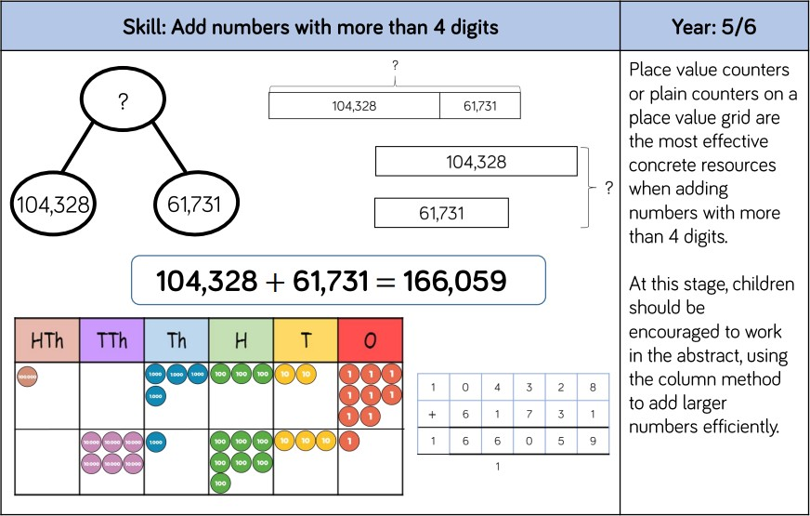
- amounts of money and measures, including those where they have to initially convert from one unit to another

Y6
End of Year Objective:
Add whole numbers and decimals using formal written methods (columnar addition).

Children should extend the carrying method and use it to add whole numbers and decimals with any number of digits.
 |  |  |  | 4 | 2
 |  | 6 | 4 | 3 | 2
 |  |  | 7 | 8 | 6
 |  |  |  |  | 3
+ |  | 4 | 6 | 8 | 1
 | 1 | 1 | 9 | 4 | 4
 | 1 | 1 | 2 | 1

 | 4 | 0 | 1 | . | 2 | 0
 |  | 2 | 6 | . | 8 | 5
+ |  |  | 0 | . | 7 | 1
 | 4 | 2 | 8 | . | 7 | 6
 |  |  | 1

When adding decimals with different numbers of decimal places, children should be taught and encouraged to make them the same through identification that 2 tenths is the same as 20 hundredths, therefore, 0.2 is the same value as 0.20.

They will also be adding:

- several numbers with different numbers of digits, understanding the place value;
- decimals with up to two decimal places (with mixed numbers of decimal places), knowing that the decimal points line up under one another.
- amounts of money and measures, including those where they have to initially convert from one unit to another.

Progression Towards a Written Method for Subtraction

In developing a written method for subtraction, it is important that children understand the concept of subtraction, in that it is:
- Removal of an amount from a larger group (take away)
- Comparison of two amounts (difference)

They also need to understand and work with certain principles, i.e. that it is:
- the inverse of addition
- not commutative i.e. 5 - 3 is not the same as 3 - 5
- not associative i.e. 10 - 3 - 2 is not the same as 10 - (3 - 2)

yr
Early Learning Goal:
Using quantities and objects, children subtract two single-digit numbers and count on or back to find the answer.

Children are encouraged to develop a mental picture of the number system in their heads to use for calculation. They should experience practical calculation opportunities using a wide variety of practical equipment, including small world play, role play, counters, cubes etc.

Taking away
Children will begin to develop their ability to subtract by using practical equipment to count out the first number and then remove or take away the second number to find the solution by counting how many are left e.g. 9 – 4.

For illustration purposes, the amount being taken away are show crossed out. Children would be encouraged to physically remove these using touch counting.

2
3
1
4

By touch counting and dragging in this way, it allows children to keep track of how many they are removing so they don’t have to keep recounting. They will then touch count the amount that are left to find the answer.
Those who are ready may record their own calculations.

Y1
End of Year Objective:
Subtract one-digit and two-digit numbers to 20, including zero (using concrete objects and pictorial representations).

Children will continue to use practical equipment and taking away strategies. To avoid the need to exchange for subtraction at this stage, it is advisable to continue to use equipment such as counters, cubes and the ones from the Base 10 equipment, but not the tens, e.g. 13 - 4

Touch count and remove the number to be taken away, in this case 4.

1
2
3
4

Touch count to find the number that remains.

1
2
3
4
5
6
7
8
9

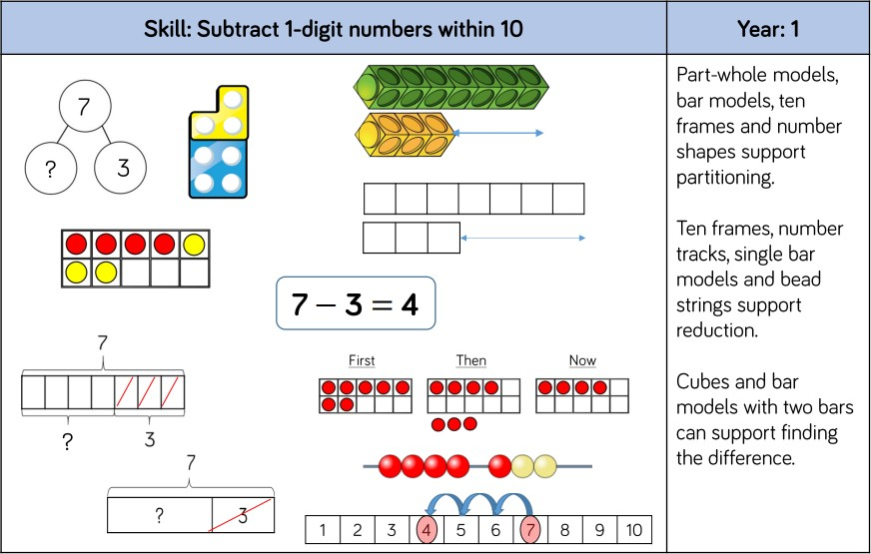

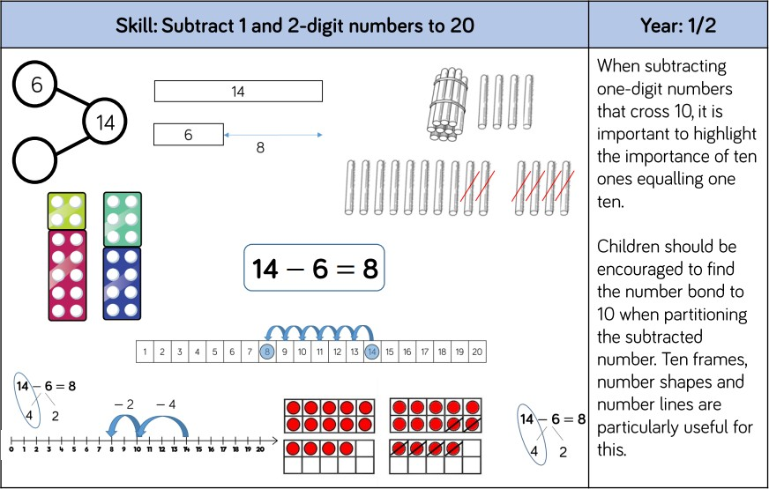

Y2
End of Year Objective:
Subtract numbers using concrete objects, pictorial representations, and mentally, including: a two-digit number and ones; a two-digit number and tens; two two-digit numbers.

Children will begin to use the Base 10 equipment to support their calculations, still using a take away, or removal, method. They need to understand that the number being subtracted does not appear as an amount on its own, but rather as part of the larger amount. For example, to calculate 54 - 23, children would count out 54 using the Base 10 equipment (5 tens and 4 units). They need to consider whether there are enough units/ones to remove 3, in this case there are, so they would remove 3 ones and then two tens, counting up the answer of 3 tens and 1 unit to give 31.

which leaves
so 54 – 23 = 31

Children can also record the calculations using their own drawings of the Base 10 equipment (as slanted lines for the 10 rods and dots for the unit blocks), e.g. to calculate 39 – 17 children would draw 39 as 3 tens (lines) and 4 ones (dots) and would cross out 7 ones and then one ten, counting up the answer of 2 tens and 2 ones to give 22.

Circling the tens and ones that remain will help children to identify how many remain.

When the amount of ones to be subtracted is greater than the ones in the original number, an exchange method is required. This relies on children’s understanding of ten ones being an equivalent amount to one ten. To calculate 53 – 26, by using practical equipment, they would count out 53 using the tens and units, as in Step 1. They need to consider whether there are enough units/ones to remove 6. In this case there are not so they need to exchange a ten into ten ones to make sure that there are enough, as in step 2.

Step 1 Step 2
becomes

The children can now see the 53 represented as 40 and 13, still the same total, but partitioned in a different way, as in step 3 and can go on to take away the 26 from the calculation to leave 27 remaining, as in Step 4.

Step 3 Step 4

When recording their own drawings, when calculating 37 – 19, children would cross out a ten and exchange for ten ones. Drawing them in a vertical line, as in Step 2, ensures that children create ten ones and do not get them confused with the ones that were already in place.

Step 1 Step 2 Step 3

Circling the tens and ones that remain will help children to identify how many remain.

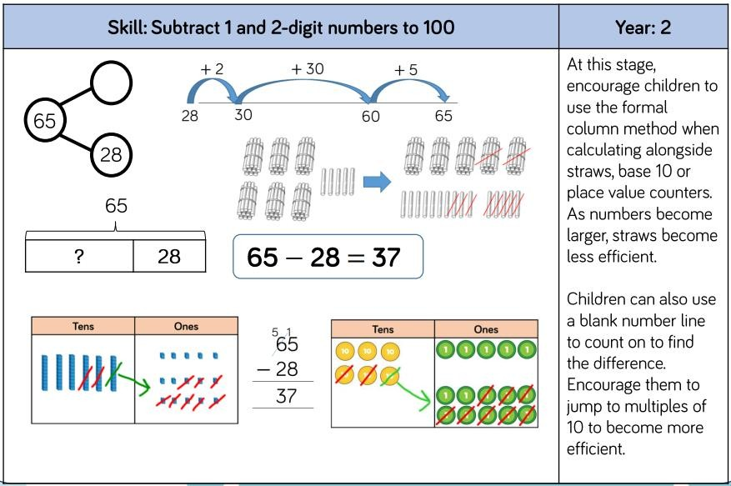

Y3
End of Year Objective:
Subtract numbers with up to three digits, using formal written method of columnar subtraction.*

*Although the objective suggests that children should be using formal written methods, the National Curriculum document states “The programmes of study for mathematics are set out year-by-year for key stages 1 and 2. Schools are, however, only required to teach the relevant programme of study by the end of the key stage. Within each key stage, schools therefore have the flexibility to introduce content earlier or later than set out in the programme of study.” p4

It is more beneficial for children’s understanding to go through the expanded methods of calculation as steps of development towards a formal written method.

Children will build on their knowledge of using Base 10 equipment from Y2 and continue to use the idea of exchange. This process should be demonstrated using arrow cards to show the partitioning and Base 10 materials to represent the first number, removing the ones and tens as appropriate (as with the more informal method in Y2).

Step 1 Step 2
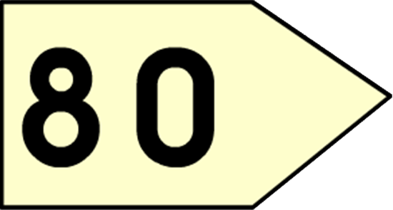
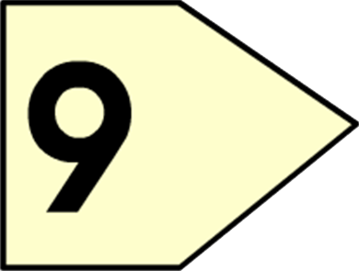
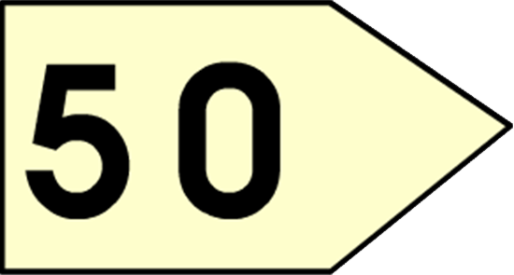
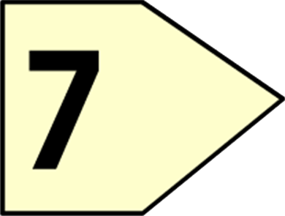

Step 3
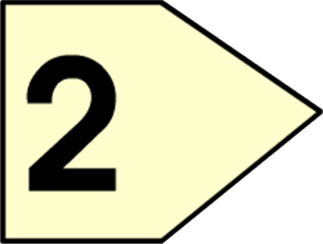
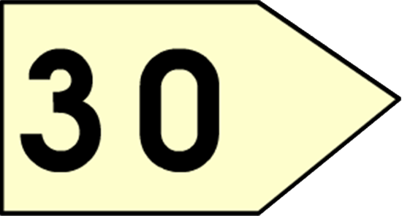

Emphasise that the second (bottom) number is being subtracted from the first (top) number rather than the lesser number from the greater.

This will be recorded by the children as:
 | 80 | → | 9
- | 50 | → | 7
 | 30 | → | 2 | = | 32

Children can also use jottings of the Base 10 materials (as in Year 2) to support with their calculation, as in the example below.
80→9-50→730→2=32

From this the children will begin to solve problems which involve exchange. Children need to consider whether there are enough units/ones to remove 6. In this case there are not (Step 1) so they need to exchange a ten into ten ones to make sure that there are enough, as they have been doing in the method for Year 2 (Step 2). They should be able to see that the number is just partitioned in a different way, but the amount remains the same (71 = 70 + 1 = 60 + 11).

Step 1 Step 2
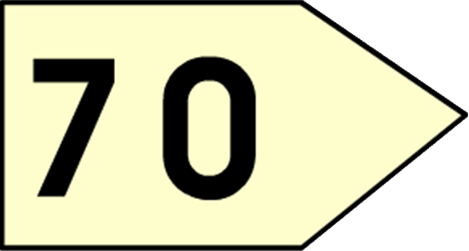
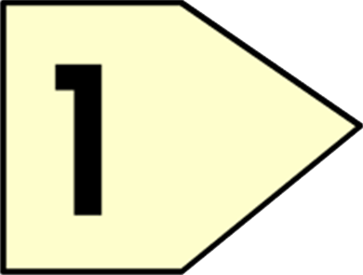
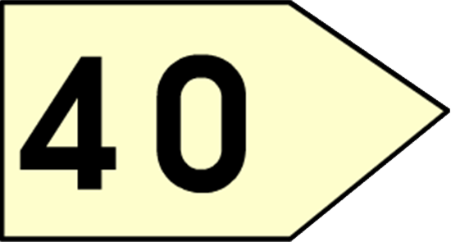
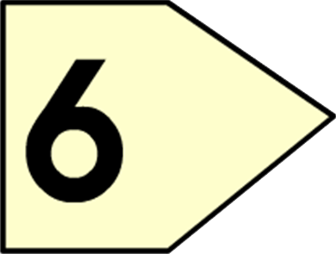
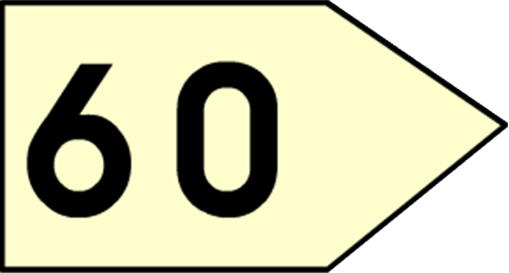
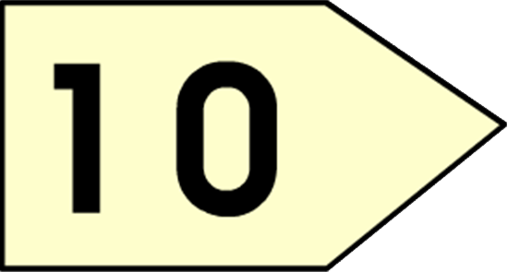

Step 3 Step 4
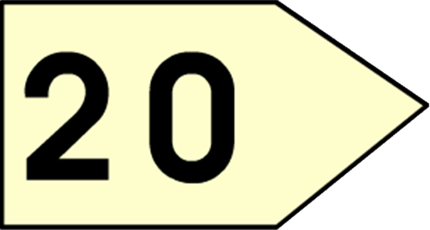
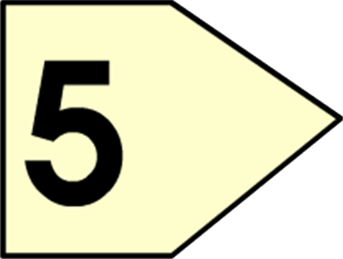

This will be recorded by the children as:

 | 60
 | 70 | → | ¹1
- | 40 | → | 6
 | 20 | → | 5 | = | 25

By the end of year 3, children should also extend this method for three digit numbers.

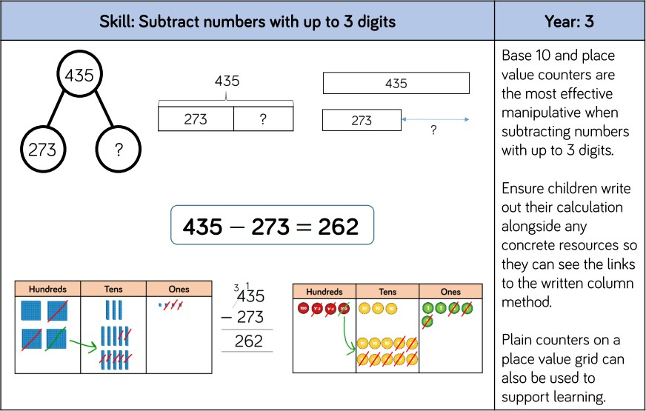
Y4
End of Year Objective:
Subtract numbers with up to 4 digits and decimals with one decimal place using the formal written method of columnar subtraction where appropriate.

Children will move to Y4 using whichever method they were using as they transitioned from Y3.

Step 1 Step 2 (exchanging from tens to units)
40700→50→¹4-200→80→6
 | 700 | → | 50 | → | 4
- | 200 | → | 80 | → | 6

Step 3 (exchanging from hundreds to tens) Step 4
600140700→50→¹4-200→80→6
600140700→50→¹4-200→80→6400→60→8=468

This would be recorded by the children as:
600140700→50→¹4-200→80→6400→60→8=468

When children are ready, this leads on to the compact method of decomposition:
₆₁₄475¹4-32861468

By the end of Y4, children should be using the written method confidently and with understanding. They will also be subtracting:

- numbers with different numbers of digits, understanding the place value;
- decimals with one decimal place, knowing that the decimal points line up under one another.

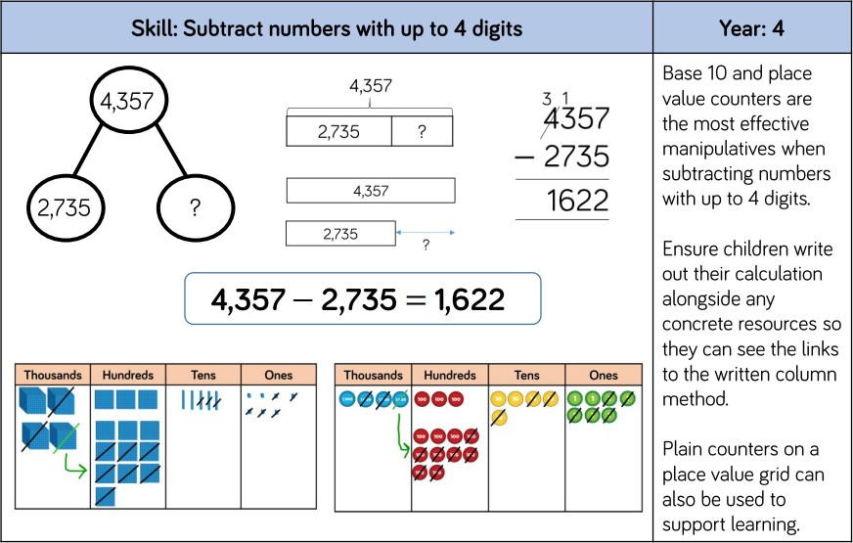

Y5
End of Year Objective:
Subtract whole numbers with more than 4 digits and decimals with two decimal places, including formal written methods (columnar subtraction).

Children should continue to use the decomposition method to solve calculations such as:

₂₁₃3.4¹2-1.7 61.6 6
₆₆7¹07¹2-3 22 63 84 6

They will also be subtracting:

- numbers with different numbers of digits, understanding the place value;
- decimals with up to two decimal places (with each number having the same number of decimal places), knowing that the decimal points line up under one another.
- amounts of money and measures, including those where they have to initially convert from one unit to another

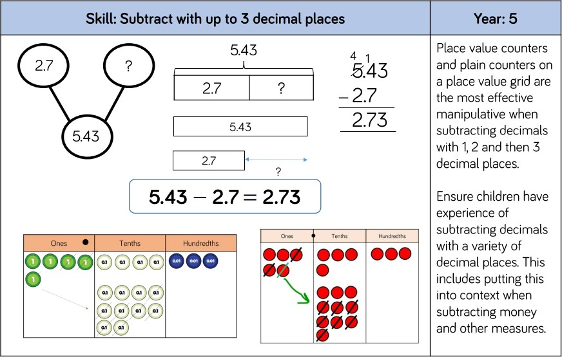

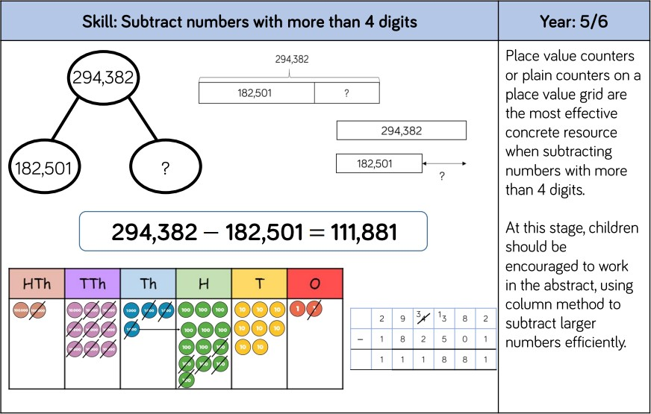
Y6
End of Year Objective:
Subtract whole numbers and decimals using formal written methods (columnar subtraction).

Children should extend the decomposition method and use it to subtract whole numbers and decimals with any number of digits.
₅₁₃64¹32-46811751
 | ₃ |  | ₆ |  | ₁₁
 | 4 | ¹1 | 7 | . | 2 | ¹0
- |  | 3 | 4 | . | 7 | 1
 | 3 | 8 | 2 | . | 4 | 9

When subtracting decimals with different numbers of decimal places, children should be taught and encouraged to make them the same through identification that 2 tenths is the same as 20 hundredths, therefore, 0.2 is the same value as 0.20.

They will also be subtracting:

- numbers with different numbers of digits, understanding the place value;
- decimals with up to two decimal places (with mixed numbers of decimal places), knowing that the decimal points line up under one another.
- amounts of money and measures, including those where they have to initially convert from one unit to another.

Progression Towards a Written Method for Multiplication

In developing a written method for multiplication, it is important that children understand the concept of multiplication, in that it is:
- repeated addition

They should also be familiar with the fact that it can be represented as an array

They also need to understand and work with certain principles, i.e. that it is:
- the inverse of division
- commutative i.e. 5 x 3 is the same as 3 x 5
- associative i.e. 2 x 3 x 5 is the same as 2 x (3 x 5)

yr
Early Learning Goal:
Children solve problems, including doubling.

Children are encouraged to develop a mental picture of the number system in their heads to use for calculation. They should experience practical calculation opportunities using a wide variety of equipment, including small world play, role play, counters, cubes etc.

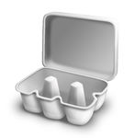
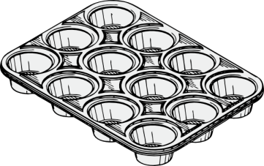
Children may also investigate putting items into resources such as egg boxes, ice cube trays and baking tins which are arrays.

They may develop ways of recording calculations using pictures, etc.
A child’s jotting showing the fingers on each hand as a double.
A child’s jotting showing double three as three cookies on each plate.

Y1
End of Year Objective:
Solve one-step problems involving multiplication by calculating the answer using concrete objects, pictorial representations and arrays with the support of the teacher.

In year one, children will continue to solve multiplication problems using practical equipment and jottings. They may use the equipment to make groups of objects. Children should see everyday versions of arrays, e.g. egg boxes, baking trays, ice cube trays, wrapping paper etc and use this in their learning, answering questions such as 'How many eggs would we need to fill the egg box? How do you know?'

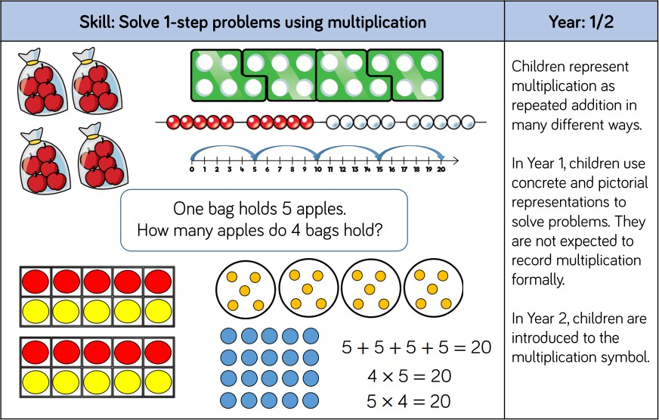

Y2
End of Year Objective:
Calculate mathematical statements for multiplication (using repeated addition) and write them using the multiplication (x) and equals (=) signs.

Children should understand and be able to calculate multiplication as repeated addition, supported by the use of practical apparatus such as counters or cubes. e.g.

5 x 3 can be shown as five groups of three with counters, either grouped in a random pattern, as below:

or in a more ordered pattern, with the groups of three indicated by the border outline:

Children should then develop this knowledge to show how multiplication calculations can be represented by an array, (this knowledge will support with the development of the grid method in the future). Again, children should be encouraged to use practical apparatus and jottings to support their understanding, e.g.

5 x 3* can be represented as an array in two forms (as it has commutativity):

5 + 5 + 5 = 15

3 + 3 + 3 + 3 + 3 = 15

*For mathematical accuracy 5 x 3 is represented by the second example above, rather than the first as it is five, three times. However, because we use terms such as 'groups of' or 'lots of', children are more familiar with the initial notation. Once children understand the commutative order of multiplication the order is irrelevant).

Y3
End of Year Objective:
Write and calculate mathematical statements for multiplication using the multiplication tables that they know, including for two-digit numbers times one-digit numbers, progressing to formal written methods.*

*Although the objective suggests that children should be using formal written methods, the National Curriculum document states “The programmes of study for mathematics are set out year-by-year for key stages 1 and 2. Schools are, however, only required to teach the relevant programme of study by the end of the key stage. Within each key stage, schools therefore have the flexibility to introduce content earlier or later than set out in the programme of study.” p4

It is more beneficial for children’s understanding to go through the expanded methods of calculation as steps of development towards a formal written method.

Initially, children will continue to use arrays where appropriate linked to the multiplication tables that they know (2, 3, 4, 5, 8 and 10), e.g.

3 x 8

They may show this using practical equipment:

3 x 8 = 8 + 8 + 8 = 24

or by jottings using squared paper:

 | x | x | x | x | x | x | x | x
 | x | x | x | x | x | x | x | x
 | x | x | x | x | x | x | x | x
3 x 8 = 8 + 8 + 8 = 24

As they progress to multiplying a two-digit number by a single digit number, children should use their knowledge of partitioning two digit numbers into tens and units/ones to help them. For example, when calculating 14 x 6, children should set out the array, then partition the array so that one array has ten columns and the other four.
10
4

Partitioning in this way, allows children to identify that the first array shows 10 x 6 and the second array shows 4 x 6. These can then be added to calculate the answer:

(6 x 10) + (6 x 4)
NB There is no requirement for children to record in this way, but it
could be used as a jotting to support development if needed.
= 60 + 24
= 84

This method is the precursor step to the grid method. Using a two-digit by single digit array, they can partition as above, identifying the number of rows and the number of columns each side of the partition line.
10
60
24
4
6

By placing a box around the array, as in the example below, and by removing the array, the grid method can be seen.

x 10 4
24

60
6

It is really important that children are confident with representing multiplication statements as arrays and understand the rows and columns structure before they develop the written method of recording.

From this, children can use the grid method to calculate two-digit by one-digit multiplication calculations, initially with two digit numbers less than 20. Children should be encouraged to set out their addition in a column at the side to ensure the place value is maintained. When children are working with numbers where they can confidently and correctly calculate the addition mentally, they may do so.

13 x 8
x | 10 | 3
 |  |  |  |  | 80
8 | 80 | 24 |  | + | 24
 |  |  |  |  | 104
When children are ready, they can then progress to using this method with other two-digit numbers.

37 x 6
x | 30 | 7
 |  |  |  |  | 180
6 | 180 | 42 |  | + | 42
 |  |  |  |  | 222

Children should also be using this method to solve problems and multiply numbers in the context of money or measures.

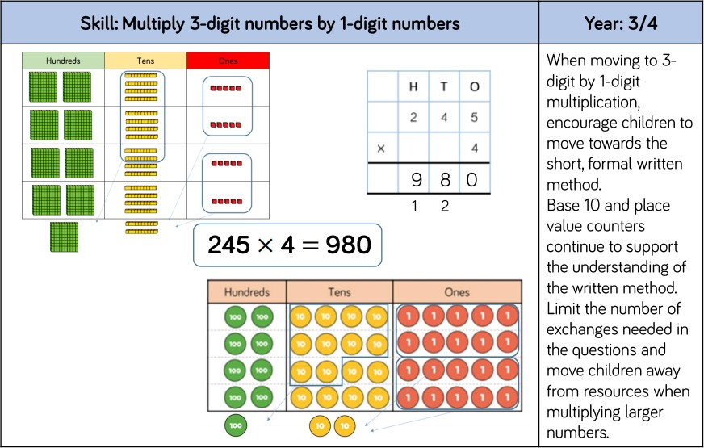

Y4
End of Year Objective:
Multiply two-digit and three-digit numbers by a one-digit number using formal written layout.

Children will move to Y4 using whichever method they were using as they transitioned from Y3. They will further develop their knowledge of the grid method to multiply any two-digit by any single-digit number, e.g.

79 x 8
x | 70 | 9
 |  |  |  |  | 560
8 | 560 | 72 |  | + | 72
 |  |  |  |  | 632

To support the grid method, children should develop their understanding of place value and facts that are linked to their knowledge of tables. For example, in the calculation above, children should use their knowledge that 7 x 8 = 56 to know that 70 x 8 = 560.

By the end of the year, they will extend their use of the grid method to be able to multiply three-digit numbers by a single digit number, e.g.

346 x 8
x | 300 | 40 | 6 |  |  | 2400
 |  |  |  |  | + | 320
8 | 2400 | 320 | 48 |  | + | 48
 |  |  |  |  |  | 2768

When children are working with numbers where they can confidently and correctly calculate the addition (or parts of the addition) mentally, they may do so.

Children should also be using this method to solve problems and multiply numbers in the context of money or measures.

Y5
End of Year Objective:
Multiply numbers up to 4 digits by a one- or two-digit number using a formal written method, including long multiplication for two-digit numbers.

Children should continue to use the grid method and extend it to multiplying numbers with up to four digits by a single digit number, e.g.

4346 x 8

x | 4 000 | 300 | 40 | 6 |  |  | 32000
 |  |  |  |  |  | + | 2400
8 | 32 000 | 2400 | 320 | 48 |  | + | 320
 |  |  |  |  |  | + | 48
 |  |  |  |  |  |  | 34768

and numbers with up to four digits by a two-digit number, e.g.

2693 x 24

x | 2000 | 600 | 90 | 3 |  |  | 40000
 |  |  |  |  |  | + | 8000
20 | 40000 | 12000 | 1800 | 60 |  | + | 12000
 |  |  |  |  |  | + | 2400
4 | 8000 | 2400 | 360 | 12 |  | + | 1800
 |  |  |  |  |  | + | 360
 |  |  |  |  |  | + | 60
 |  |  |  |  |  | + | 12
 |  |  |  |  |  |  | 64632

When children are working with numbers where they can confidently and correctly calculate the addition (or parts of the addition) mentally, they may do so.

Children should also be using this method to solve problems and multiply numbers in the context of money or measures.
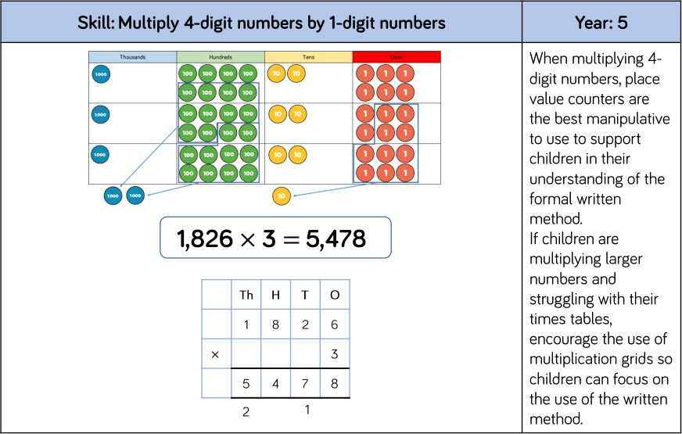
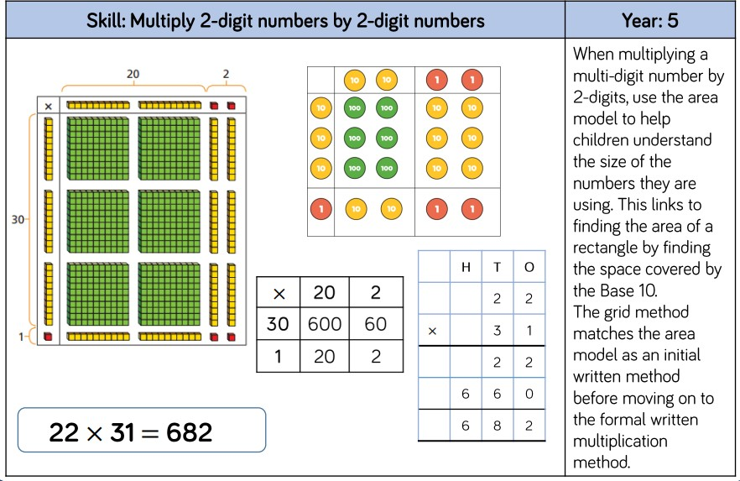

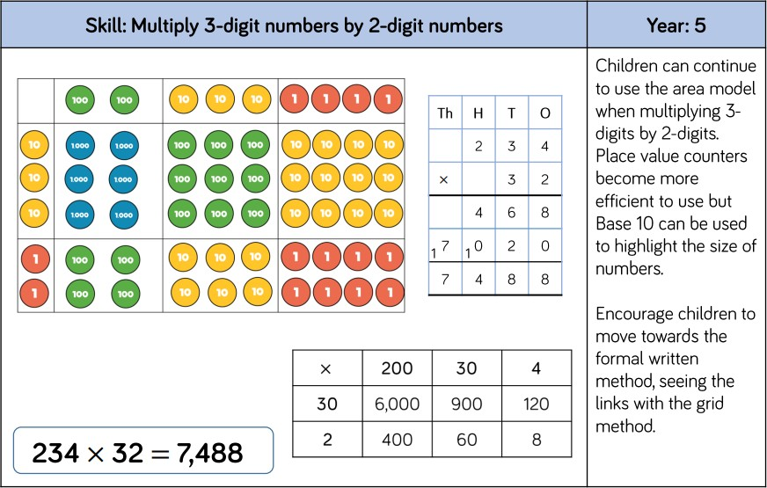

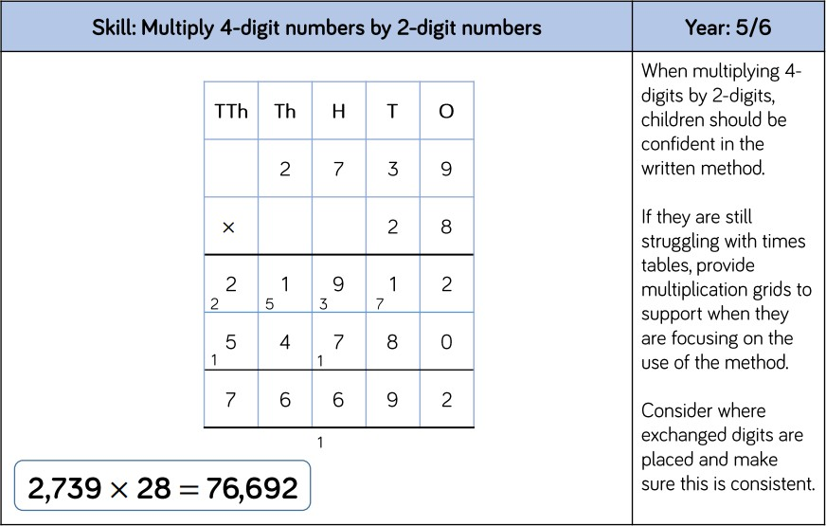

Y6
End of Year Objective:
Multiply multi-digit numbers up to 4 digits by a two-digit whole number using the formal written method of long multiplication.
Multiply one-digit numbers with up to two decimal places by whole numbers.

By the end of Y6, children should be able to use the grid method to multiply any number by a two-digit number. They should also develop the method to be able to multiply decimal numbers with up to two decimal places, e.g.

4.92 x 3
x | 4 | 0.9 | 0.02 |  |  | 12
 |  |  |  |  | + | 2.7
3 | 12 | 2.7 | 0.06 |  | + | 0.06
 |  |  |  |  |  | 14.76

When children are working with numbers where they can confidently and correctly calculate the addition (or parts of the addition) mentally, they may do so.

Children should also be using this method to solve problems and multiply numbers, including those with decimals, in the context of money or measures, e.g. to calculate the cost of 7 items at £8.63 each, or the total length of six pieces of ribbon of 2.28m each.

Progression Towards a Written Method for Division

In developing a written method for division, it is important that children understand the concept of division, in that it is:
- repeated subtraction
- sharing into equal amounts

They also need to understand and work with certain principles, i.e. that it is:
- the inverse of multiplication
- not commutative i.e. 15 ÷3 is not the same as 3 ÷ 15
- not associative i.e. 30 ÷ (5 ÷ 2) is not the same as (30 ÷ 5) ÷ 2

yr
Early Learning Goal:
Children solve problems, including halving and sharing.

Children are encouraged to develop a mental picture of the number system in their heads to use for calculation. They should experience practical calculation opportunities using a wide variety of equipment, including small world play, role play, counters, cubes etc.

Children may also investigate sharing items or putting items into groups using items such as egg boxes, ice cube trays and baking tins which are arrays.

They may develop ways of recording calculations using pictures, etc.
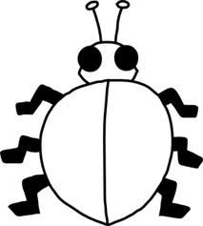
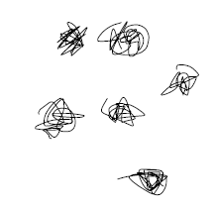
A child’s jotting showing halving six spots between two sides of a ladybird.

A child’s jotting showing how they shared the apples at snack time between two groups.

Y1
End of Year Objective:
Solve one-step problems involving division by calculating the answer using concrete objects, pictorial representations and arrays with the support of the teacher.

In year one, children will continue to solve division problems using practical equipment and jottings. They should use the equipment to share objects and separate them into groups, answering questions such as 'If we share these six apples between the three of you, how many will you each have? How do you know?' or ‘If six football stickers are shared between two people, how many do they each get?’ They may solve both of these types of question by using a 'one for you, one for me' strategy until all of the objects have been given out.

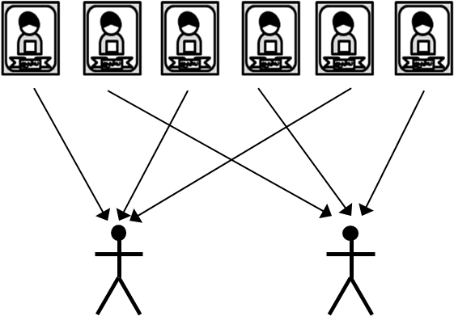

Children should be introduced to the concept of simple remainders in their calculations at this practical stage, being able to identify that the groups are not equal and should refer to the remainder as ‘… left over.’

Y2
End of Year Objective:
Calculate mathematical statements for division within the multiplication tables and write them using the division (÷) and equals (=) signs.

Children will utilise practical equipment to represent division calculations as grouping (repeated subtraction) and use jottings to support their calculation, e.g.

12 ÷ 3 =

Children need to understand that this calculation reads as 'How many groups of 3 are there in 12?'

They should also continue to develop their knowledge of division with remainders, e.g.

13 ÷ 4 =

13 ÷ 4 = 3 remainder 1

Children need to be able to make decisions about what to do with remainders after division and round up or down accordingly. In the calculation 13 ÷ 4, the answer is 3 remainder 1, but whether the answer should be rounded up to 4 or rounded down to 3 depends on the context, as in the examples below:

I have £13. Books are £4 each. How many can I buy?
Answer: 3 (the remaining £1 is not enough to buy another book)

Apples are packed into boxes of 4. There are 13 apples. How many boxes are needed?
Answer: 4 (the remaining 1 apple still needs to be placed into a box)

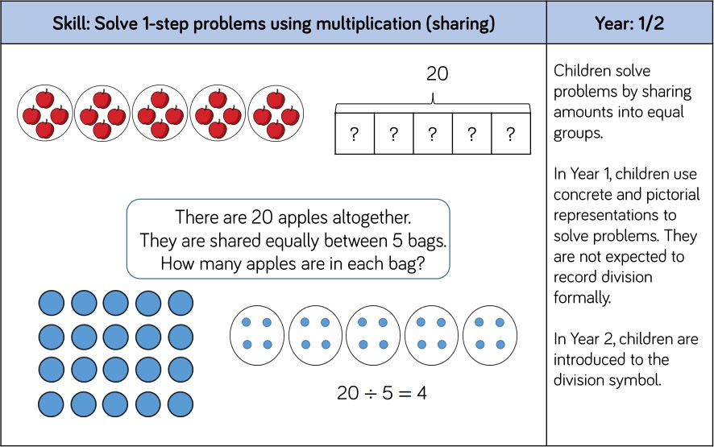
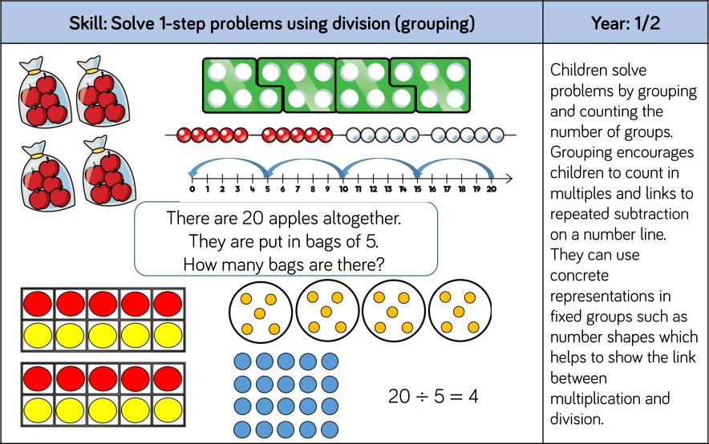

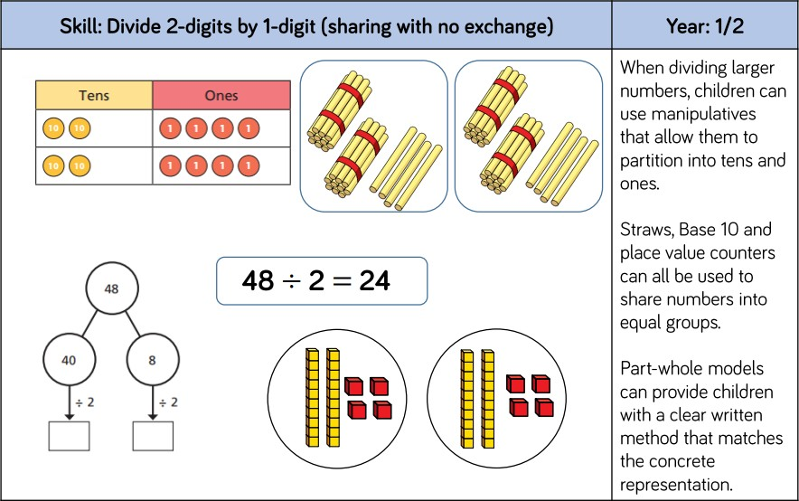

Y3
End of Year Objective:
Write and calculate mathematical statements for division using the multiplication tables that they know, including for two-digit numbers divided by one-digit numbers, progressing to formal written methods.*

*Although the objective suggests that children should be using formal written methods, the National Curriculum document states “The programmes of study for mathematics are set out year-by-year for key stages 1 and 2. Schools are, however, only required to teach the relevant programme of study by the end of the key stage. Within each key stage, schools therefore have the flexibility to introduce content earlier or later than set out in the programme of study.” p4

It is more beneficial for children’s understanding to go through the expanded methods of calculation as steps of development towards a formal written method.

Initially, children will continue to use division by grouping (including those with remainders), where appropriate linked to the multiplication tables that they know (2, 3, 4, 5, 8 and 10), e.g.

43 ÷ 8 =

43 ÷ 8 = 5 remainder 3

In preparation for developing the ‘chunking’ method of division, children should first use the repeated subtraction on a vertical number line alongside the continued use of practical equipment. There are two stages to this:

Stage 1 – repeatedly subtracting individual groups of the divisor
Stage 2 – subtracting multiples of the divisor (initially 10 groups and individual groups, then 10 groups
and other multiples in line with tables knowledge)

After each group has been subtracted, children should consider how many are left to enable them to identify the amount remaining on the number line.

Stage 1 Stage 2
56 ÷ 4 = 14 (groups of 4) 56 ÷ 4 = 10(groups of 4) + 2(groups of 4) + 2(groups of 4)
= 14(groups of 4)
56

52

48

44

40

36

32

28

24

20

16

12

8

4

0
56

16

8

0
10 groups
2 groups
2 groups

Children should be able to solve real life problems including those with money and measures. They need to be able to make decisions about what to do with remainders after division and round up or down accordingly.

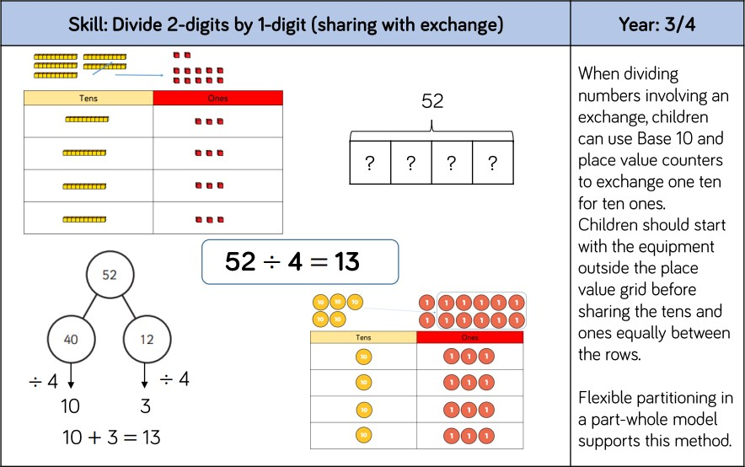
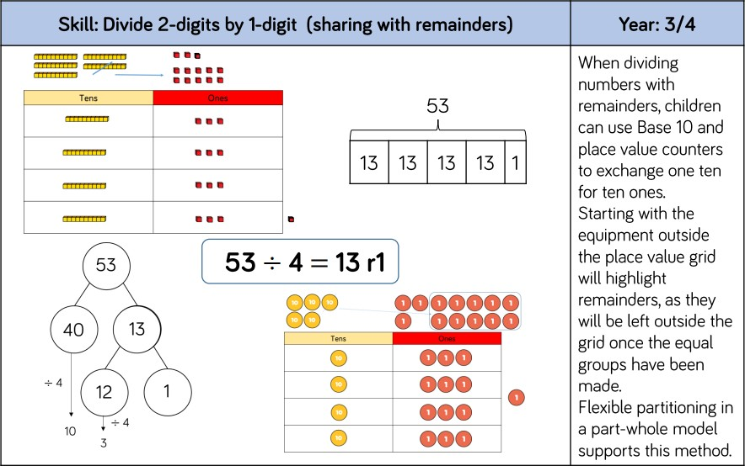

Y4
End of Year Objective:
Divide numbers up to 3 digits by a one-digit number using the formal written method of short division and interpret remainders appropriately for the context.

Y5

Children will continue to develop their use of grouping (repeated subtraction) to be able to subtract multiples of the divisor, moving on to the use of the 'chunking' method.

56

16

0
10 groups
4 groups
14
56
40
16
16
0
4
Children should write their answer above the calculation to make it easy for them and the teacher to distinguish.

10x

4x
-
-
The number line method used in year 3 can be linked to the chunking method to enable children to make links in their understanding.

Answer: 14

When developing their understanding of ‘chunking’, children should utilise a ‘key facts’ box, as shown below. This enables an efficient recall of tables facts and will help them in identifying the largest group they can subtract in one chunk. Any remainders should be shown as integers, e.g.

73 ÷ 3
24r1
73
30
43
30
13
6
7
6
1
10x

10x

2x

2x
3
-
-
-
-
1x 3
2x 6
5x 15
10x 30
Key facts box

By the end of year 4, children should be able to use the chunking method to divide a three digit number by a single digit number. To make this method more efficient, the key facts in the menu box should be extended to include 4x and 20x, e.g.

196 ÷ 6
1x 6
2x 12
4x 24
5x 30
10x 60
20x 120
Key facts box
32r4
196
120
76
60
16
12
4

20x

10x

2x
6
-
-
-

Children should be able to solve real life problems including those with money and measures. They need to be able to make decisions about what to do with remainders after division and round up or down accordingly.

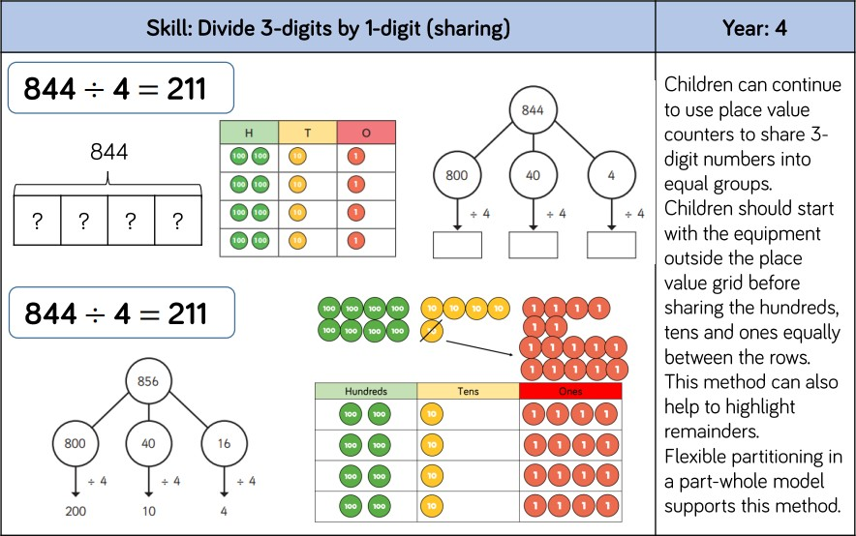
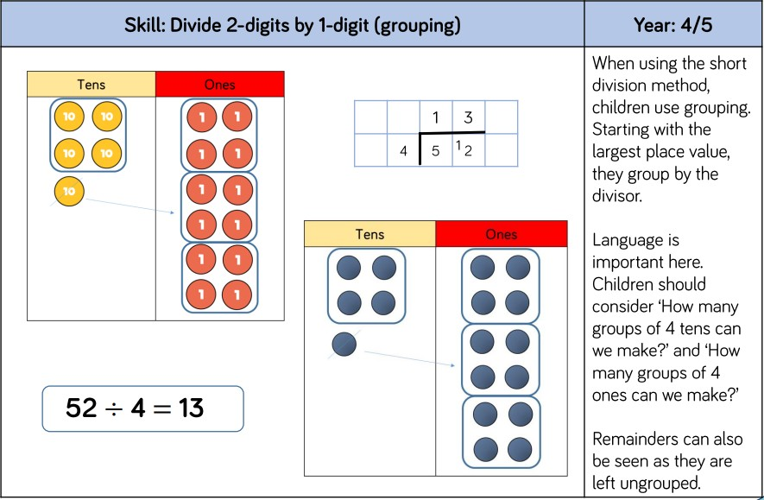

Y5
End of Year Objective:
Divide numbers up to 4 digits by a one-digit number using the formal written method of short division and interpret remainders appropriately for the context.

Children may continue to use the key facts box for as long as they find it useful. Using their knowledge of linked tables facts, children should be encouraged to use higher multiples of the divisor. Any remainders should be shown as integers, e.g.

523 ÷ 8
65r3
523
320
203
160
43
40
3

40x

20x

5x
8
-
-
-

By the end of year 5, children should be able to use the chunking method to divide a four digit number by a single digit number. If children still need to use the key facts box, it can be extended to include 100x.

2458 ÷ 7
351r1
2458
2100
358
350
8
7
1
300x

50x

1x
7
-
-
-

Children should be able to solve real life problems including those with money and measures. They need to be able to make decisions about what to do with remainders after division and round up or down accordingly.

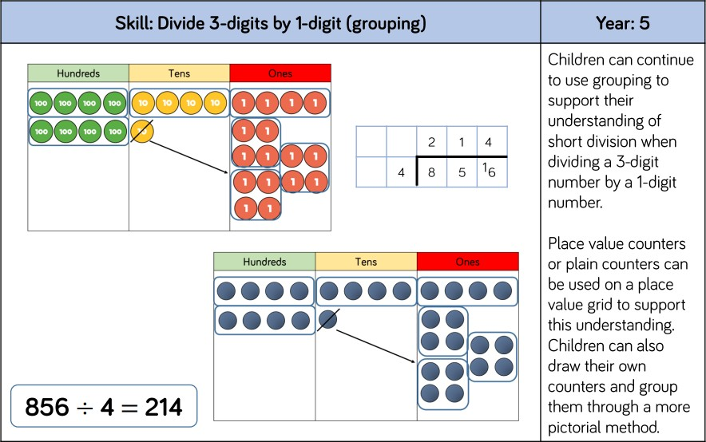

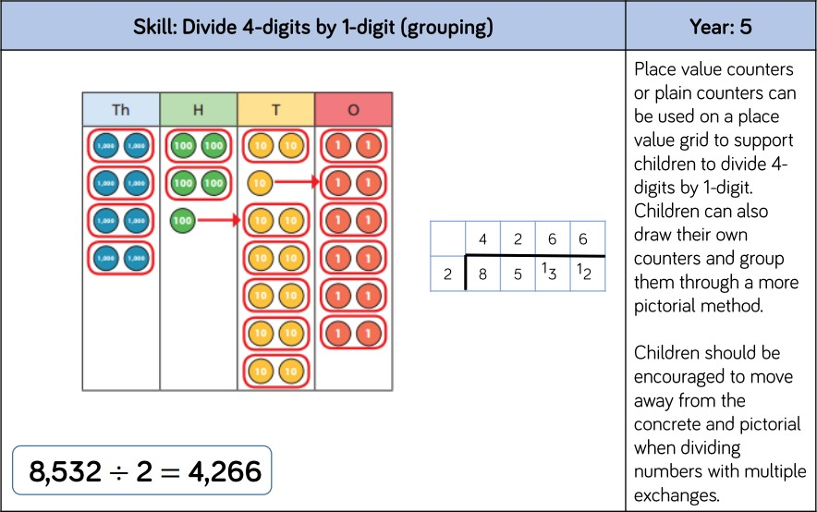

Y6
End of Year Objective:
Divide numbers up to 4 digits by a two-digit number using the formal written method of short division where appropriate, interpreting remainders according to the context.
Use written division methods in cases where the answer has up to two decimal places.

To develop the chunking method further, it should be extended to include dividing a four-digit number by a two-digit number, e.g.

6367 ÷ 28
227r11
6367
5600
767
560
207
140
67
56
11
28
-
-
-
-

200x

20x

5x

2x

Children should be able to solve real life problems including those with money and measures. They need to be able to make decisions about what to do with remainders after division and round up or down accordingly.

In addition, children should also be able to use the chunking method and solve calculations interpreting the remainder as a decimal up to two decimal places, e.g. 362 ÷ 17

362 ÷ 17
17
-
-
-
-
21.29
362
340
22
17
5.0
3.4
1.60
1.53
0.07
20x

1x

0.2x

0.09x
To enable children to continue the calculation, they need to understand that 5 is the same as 5.0

When recalling and deriving multiplication and division facts, children should also identify decimal equivalents of times tables,
e.g. if 2 x 17 = 34, I know that 0.2 x 17 = 3.4
if 9 x 17 = 153, 0.9 x 17 = 15.3 so 0.09 x 17 = 1.53

For simple fraction and decimal equivalents, this could also be demonstrated using a simple calculation such as 13 ÷ 4 to show the remainder initially as a fraction.

Using practical equipment, children can see that for 13 ÷ 4, the answer is 3 remainder 1, or put another way, there are three whole groups and a remainder of 1. This remainder is one part towards a full group of 4, so is . To show the remainder as a fraction, it becomes the numerator where the denominator is the divisor (the number that you are dividing by in the calculation).

3574 ÷ 8

3574
3200
374
320
54
48
6
remainder
divisor
6
8
400x

40x

6x
8
-

-

So 3574 ÷ 8 is 446
(when the remainder is shown as a fraction)

-

To show the remainder as a decimal relies upon children’s knowledge of decimal fraction equivalents. For decimals with no more than 2 decimal places, they should be able to identify:

Half: = 0.5
Quarters: = 0.25, = 0.75
Fifths: = 0.2, = 0.4, = 0.6, = 0.8
Tenths: = 0.1, = 0.2, = 0.3, = 0.4, = 0.5, = 0.6, = 0.7, = 0.8, = 0.9

and reduce other equivalent fractions to their lowest terms.
In the example above, 3574 ÷ 8, children should be able to identify that the remainder as a fraction of can be written as in its lowest terms. As is equivalent to 0.75, the answer can therefore be written as 446.75
