Attendance and Punctuality
Last week’s whole school attendance was 97.5% - FANTASTIC!
CONGRATULATIONS to Class 4 who were last week’s AWESOME ATTENDERS with 100% attendance!
CONGRATULATIONS to Class 4 who were last week’s PUNCTUALITY SUPERSTARS!

THIS TERM’s TEAM POINTS

Congratulations to all the children in SENSET!
Crag  13,007 | Hutton  11,900 | Senset  13,404 | Washington  13,277

END OF TERM AWARDS

This academic year, our End of Term Awards will focus on the key subjects that have been taught in the term.
For the Autumn Term this includes Computing, Design Technology, Geography, Science, Writing and Mathematics. Design Technology has supported the children’s learning in Science with Class 1 and Class 2 learning about animals in Science and making an animal with a moving mouth using pneumatics. Class 3 have learnt about light and shadows in Science, written their own fable in English then created shadow puppets and a theatre. I watched the film of some of their shadow puppet fables this morning – that made me appreciate all the different skills children used in achieving their end goal. Class 4 have been learning about animal classification and evolution in Science – their home learning to research key scientists such as Charles Darwin has been really impressive.
These awards really celebrate children’s cross-curricular achievements – WELL DONE EVERYBODY!

Award | Class 1 | Class 2 | Class 3 | Class 4
Competent Computer Coder | Jake  Bagguley | Thomas  Hizzard | Ava  Bayman | Lucas  Richardson
Determined Design Technologist | Annalise  Bagguley | Lily  Roberts-Procter | Georgia  Darwell | Dylan  Armstrong
Genius Geographer | Lealand  Halton | Isaac  Holmes | Kerr  Slaughter | Ella  Brayshaw
Scientific Superstar | Amelie  Fairclough | Connie  Lawrence | Mya  Milner | Lola  McVety
Impressive Writer | Baylee  Jackson | Freddie  Whittam | Ruby  Adamson | Martin  Nixon
Most Improved Mathematician | Leon  Hughes | Amalie  Robinson | Brandon  Varley | Cole  Evans

EARTH AWARDS  Congratulations to this week’s Earth Award winners:  Shane Bradley, Oliver Robinson, Scarlett Gonter, Evie Bellinger, Jaxon Walsh, Isabelle Halton, Isaac Holmes, Freddie Whittam, Mason Milner, Chase Robinson, Kerr Slaughter, Anna McFall, Laurence Stallard, Mya Milner, Reece Walsh, Cole Evans and William Hamling.  VENUS AWARDS  Congratulations to this week’s Venus Award winner:  Brandon Varley | 

I’m Gonna Shine!
BRILLIANT! FANTASTIC! AMAZING! IMPRESSIVE! WONDERFUL!
What more do I need to say!
Performers from Class 1 and Class 2 with narrators and shepherds from
Class 4 did a fabulous job reading, singing, dancing and acting on stage.
The supporting choir of Class 3 and Class 4 children sang beautifully.
The introduction of foreign languages, harmonies and solo or small group singers made ‘I’m Gonna Shine’ really special.
WELL DONE to all our amazing performers! Thank you to all those parents, carers and family members who joined us! A HUGE THANK YOU to Mr McGurk and Miss.Fearon, our very own Tim Rice and Andrew Lloyd-Webber!

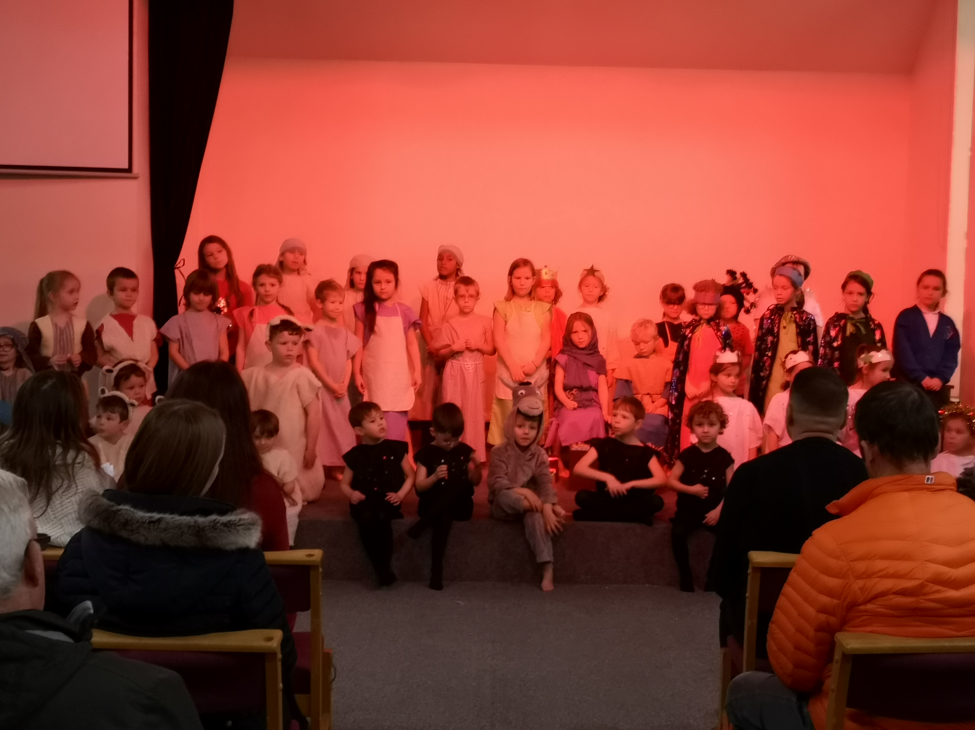

Parent Teacher Meetings will be on Thursday 16th January.
You can now book your appointment times on the school website.
Any new parents who are unsure what to do should contact
Mrs Robinson (after the holidays) who will offer assistance.

Invention Convention
Yesterday we held our very first Invention Convention.
Children worked in their four mixed age teams to design, test and review inventions that will address a given challenge such as building a raft that floats with a 20g weight, a bridge that spans 18cm and the tallest tower made of only paper. Ask your children what they learnt from this.
This is some of Class 4’s feedback:
‘Using the creative side of your brain meant you had to think differently and work out how to put everyone’s ideas together.’ Lola (Senset)
‘It was good! We worked with children of different ages. We all had different minds and different ideas so it really was a team effort.’ Ella (Hutton)
‘Getting to work with the younger children was great. Building a raft together was fun, our team won – so that was great!!!’ Tom (Washington)
‘The invention convention was fun – designing builds which we could test was a good use of team work.’ Max (Crag)

P.T.A. CHRISTMAS FAIR
Many thanks to the P.T.A. for organising such an amazing Christmas Fair last Friday! Thanks to everyone who helped with preparations, donations, running stalls, clearing up and spending money!
GRAND TOTAL = £835
This is fantastic achievement – well done to all involved!

IMPORTANT: Primary Admissions for September 2020

Do you have a child starting primary school in September 2020?
APPLY NOW for a school place on www.lancashire.gov.uk/schools or call 01524 581148

Closing date: 15 JANUARY 2020

Check this academic year’s calendar on our website
www.archbishophuttons.lancs.sch.uk
What’s happening next half-term term?

Mon 6th Jan | 8.45am School re-opens for the Spring Term
Mon 6th Jan | CLASS 3 start swimming lessons every Monday pm
Wed 15th Jan | Closing date for PRIMARY SCHOOL APPLICATIONS
Thu 16th Jan | PARENT TEACHER MEETINGS: BOOK YOUR APPOINTMENT NOW
Thu 23rd Jan | School Sports Partnership Cross Country event being held on our school field
Mon 27th Jan | China Experience – visitors from Lancaster University will be leading workshops about Chinese culture with every class
Tue 28th Jan | Radio 2 5,000 words competition opens
Fri 31st Jan | Celebration Assembly starts at 2.20pm when there will be a presentation about the local Beavers and Cubs packs
Fri 14th Feb | School finishes at 3.10pm for half-term

THANK YOU for all your support this term.
Wishing you a very Merry Christmas and a Happy New Year
from Miss Watson and all the staff
