Attendance and Punctuality
Last week’s whole school attendance was 98.4% - FANTASTIC!
CONGRATULATIONS to Class 2 who were last week’s 100% PERFECT ATTENDERS - AMAZING!
CONGRATULATIONS to Class 1 and Class 2 who were last week’s PUNCTUALITY SUPERSTARS!

Congratulations to our Learners of the Week for
Excellent Presentation
Class 1 | Annalise Bagguley | Scarlett Gonter
Class 2 | Abi Hodkin | Sam Price
Class 3 | Ryan McKenzie | Faith Hamling
Class 4 | Grace Cook | Lola McVety

Mega Maths Heroes | Congratulations to this week’s Mega Maths Heroes!  You can admire their marvellous maths learning in their class folder.  These are displayed in the school entrance – enjoy looking at them!
Class 1 | Leon Hughes
Class 2 | Evie Bellinger
Class 3 | Kacey Pickup
Class 4 | Oscar Langman

This week’s team points | Congratulations to all the children in Hutton!
This week’s team points | Crag  917 | Hutton  974 | Senset  876 | Washington  973

MARS AWARDS  Congratulations to this week’s Mars Award winner: Abi Hodkin, Sam Price, Amalie Robinson, Georgia Holmes and Marcie Dowsett  EARTH AWARDS  Congratulations to this week’s Earth Award winners: Kacey Pickup, Jack Edmondson, Tulisha Sharples, Katie Denney and Harry Pickup. | 

Congratulations to this week’s OUTSTANDING LEARNERS!

Frankie Ashworth, Evan Price and Archie Alty

Cross Country Success!
Yesterday afternoon, our school hosted a cross country event, the first School Sports Partnership of this academic year. Eight schools joined in with nearly 200 children running three times round our course. Our mixed team of Year 4, Year 5 and Year 6 children did a stunning job achieving great success as the competition winners earning 80 points between them!!! Archie Spicer came first with Harry Liley second in Year 5 boys’ race; Ella Brayshaw and Grace Cook came second and third in the Year 5 girls’ race. Many thanks to Mrs Gavriluk and Tim Fletcher (School Sports Partnership Co-ordinator) who organised this event! Thanks to all those parent/grandparent volunteers and members of Class 4 for their marshalling skills and to Ian McVety, our chief photographer.
CONGRATULATIONS to our impressive team of cross country runners – you were BRILLIANT!
 | 

Radio 2 500 Words 2020
The UK's largest story writing competition for kids is back for its tenth year. Here's everything you need to know to get involved.

How to enter
All stories must be submitted via the online form on our BBC Radio 2 – 500 Words 2020 website.
Please read the competition rules before submitting entries, along with the competition Privacy Notice.

What are the prizes?
As well as attending a spectacular 500 Words Final at Buckingham Palace where superstar celebrities will read the winning stories live on the radio, six amazing illustrators: Tony Ross, Fiona Lumbers, David McKee, Sue Cheung, David Roberts, and Margaret Sturton – will each be set the task of illustrating one of the winning stories.
The winners in each age category will also receive:
Gold Winners - Chris Evans' height in books and 500 books for their school.
Silver Winners - HRH The Duchess of Cornwall's height in books.
Bronze Winners - Their own height in books.
There is also a BRAND NEW Prize for 2020 and it doesn’t matter how good your story is just that you enter one. One entrant will be selected at random to receive a fabulous book bundle and an invite to the final (for child plus a parent or guardian). They will also win 500 books for their school – so the more pupils a school has that has entered the more chances they have of winning a brand new library.

Dates for your diary
All entries must be received by Thursday 27th February at 8pm.
This year’s 500 Words Final will be broadcast live on BBC Radio 2 from Buckingham Palace, on The Zoe Ball Breakfast Show, on Friday 12th June.

Get started
500 Words is an open invitation to the wide world of imagination, so it's time to get those creative cogs turning!
To help you get started, our website is packed full of helpful hints and terrific tips to bust through the writer's block.
So have a go and get writing your 500 word story!

 | 
Gong hei fat choy or Happy New Year!
Tomorrow is the Chinese New Year,
Chinese New Year is the Chinese festival that celebrates the beginning of a new year on the traditional Chinese calendar.
On Monday we will be welcoming visitors from Lancaster University who will be leading workshops about Chinese culture with every class throughout the day.
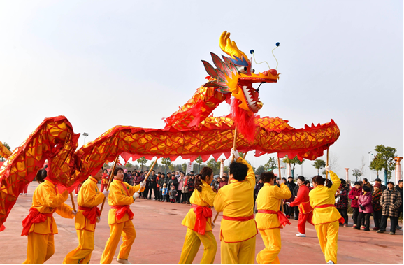

Healthy Snack Guidance
We allow children to have a healthy snack at morning playtime. Children in EYFS and Key Stage 1 (Class 1 and Class 2) are provided with a piece of fruit or vegetable. Parents of children in Key Stage 2 (Class 3 and Class 4) have the option to provide their child with a healthy snack.
There has been some confusion about what constitutes a healthy snack. After looking at NHS advice and understanding the need for clarity, we have decided that in our school, a healthy snack is a piece of fruit or vegetable.
In order to reduce waste and costs, we recommend Key Stage 2 children bring their healthy snacks to school in a reusable plastic container. All fruit and vegetable waste will be composted on school grounds.
We would appreciate parents following this guidance from Monday 20th January.

Check this academic year’s calendar on our website
www.archbishophuttons.lancs.sch.uk
What’s happening this term?

Mon 27th Jan | China Experience – Visitors from Lancaster University will be leading workshops about Chinese culture with every class throughout the day
Fri 31st Jan | Celebration Assembly starts at 2.20pm beginning with a presentation about the local Beavers and Cubs packs
Tue 11th Feb | Food Fusions – East Meets West special lunch to celebrate Chinese New Year
Fri 14th Feb | School finishes at 3.10pm for half-term  Re-opens at 8.45am on Monday 24th February
Tue 25th Feb | Pancake Day – Every child having a school meal gets pancakes for dessert
Thu 27th Feb 8pm | Radio 2 500 Words competition closes
Sat 29th Feb  8pm | P.T.A. Leap Year Party Warton Village Hall - Tickets now available from the School Office
Mon 2nd Mar | Secondary School offers issued
Thu 5th Mar | Rural Schools’ Swimming Gala
Wed 25 Mar | Classes 3 & 4 at Borwick Hall
Thu 26 Mar | Classes 1 & 2 at Borwick Hall
Tue 31st Mar | Easter Lunch
Thu 2nd Apr  2pm | Easter Service at St Oswald’s Church
Thu 2nd Apr  6.30pm | P.T.A. Easter Bingo in school hall

