PHASED RETURN DELAYED
Dr Sakthi Karunathini (Director of Public Health and Wellbeing for Lancashire County Council) issued a statement on 27/05/20 ‘advising schools in the county not to open to more pupils from 1 June, but instead to continue with the current arrangements. This is because, in our assessment, we do not currently meet all five of the government's tests in Lancashire which would allow this decision to be taken safely.’ Parents can read the full statement on the 28/05/20 blog.
As a result of this statement, we have delayed the start of our planned phased return.
What next for our school?
- We will continue to provide childcare for key worker families
- Staff will still have an inset day on Monday 1st June in order to plan for a phased return to school at the point when Lancashire County Council deems it safe to do so
- We will not be opening for any other groups of children e.g. YR, Y1 and Y6 until Lancashire County Council deems it safe to do so
- Teachers will continue to provide all children with home learning, promote interaction and give feedback to children through the Pupil Area
- We will continue to keep parents up-to-dates about future changes through the School Spider app and emails
CHILDCARE for next week (beginning Mon 1st June)
As usual,
- parents book childcare for days they are working using the school form
- childcare will start from 8.45a.m. and finish at 3.10p.m.
- children can wear their own clothes with sensible shoes or trainers
- children need to bring a packed lunch with them - they will continue to use their school water bottles
Thank you for your continued support in these changing circumstances!

 | Congratulations to Mrs. Galbraith whose new baby boy arrived last Sunday.  Mother and baby are both doing well.  Mrs. Galbraith works as a  Teaching Assistant in Class 4.  We wish all the Galbraith family good health and much happiness with their new addition!
Keeping in touch  Keeping in touch throughout the next few weeks is going to be more important than ever.  As you already know, our current text service end this Sunday, 31st May.  From 1st June all contact will be via email and alerts on the School Spider app.  Emails will be checked daily during the week.  We will confirm telephone access from Tuesday 2nd June when have confirmed which times of the week the office will be staffed. |  | 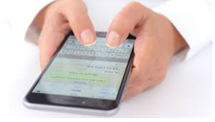
Why do parents need to download the School Spider app?
Why parents should use the School Spider app:
- keep up to date with recent calendar, news and gallery posts
- to receive smart phone messages and emails from school
- to complete surveys and forms about home learning, school visits etc.
- to book Parent Teacher Meeting appointments
How do parents access the School Spider app:
- Download the free app from Google Play store or Apple App store
- Use the drop down and select Archbishop Hutton's Primary School
- You can then see recent news, gallery, calendar and blog posts
- Next you will need to login to receive any communication related to your child
- You have already received your parent login from school so check your texts to find this. When you cannot find your login send Mrs. Robinson a text asking for your login
- When you have logged in, you do not need to do anything at all. You will receive an email and an app notification to tell you when you have been sent new information
- After that, everything is self-explanatory
- Further School Spider app information can be found on 08/05/20 BLOG ON www.archbishophuttons.lancs.sch.uk to find out how to load the app. This includes a YouTube parent tutorial.
What next?
- From 1st June, we will no longer be using the Teacher2Parent text service. Home school contact will be via the School Spider app linked to the school website
Our next step for making the most of our School Spider app, will be setting up online payments for school dinners, trips and music lessons.
ONLY 2 MORE DAYS UNTIL THE TEXT SERVICE ENDS SO MAKE SURE YOU HAVE SET UP THE SCHOOL SPIDER APP ON YOUR PHONE! |  |  | 

Home Learning Reminder for Parents/Carers:
- Home learning for each week will be available from Friday - this gives parents time to print off any information their child needs ready to get going first thing on Monday morning
- ALL children will need a printed copy of the weekly guide created by the teachers - this tells the child what they should do every day
- ALL children should record answers to questions and activities in the exercise book provided. Spare exercise books are available from the school entrance porch during school opening hours
- For children who have on-going access to a device for their home learning the only document that should be printed out is the weekly guide. There is no need to print out worksheets for them to refer to as they have this information on screen
- For children who are not working from a device, then worksheets will need printing out for them to use
- Teachers have included their school email addresses at the top of each week’s Home Learning Guide. This will enable parents to contact their child’s teacher directly with queries or concerns relating to home learning.

BARN UPDATE  The barn will be demolished during the week beginning Monday 15th June.  Pedestrians will be able to walk safely past the barn. Work will start after the beginning of the school day. | 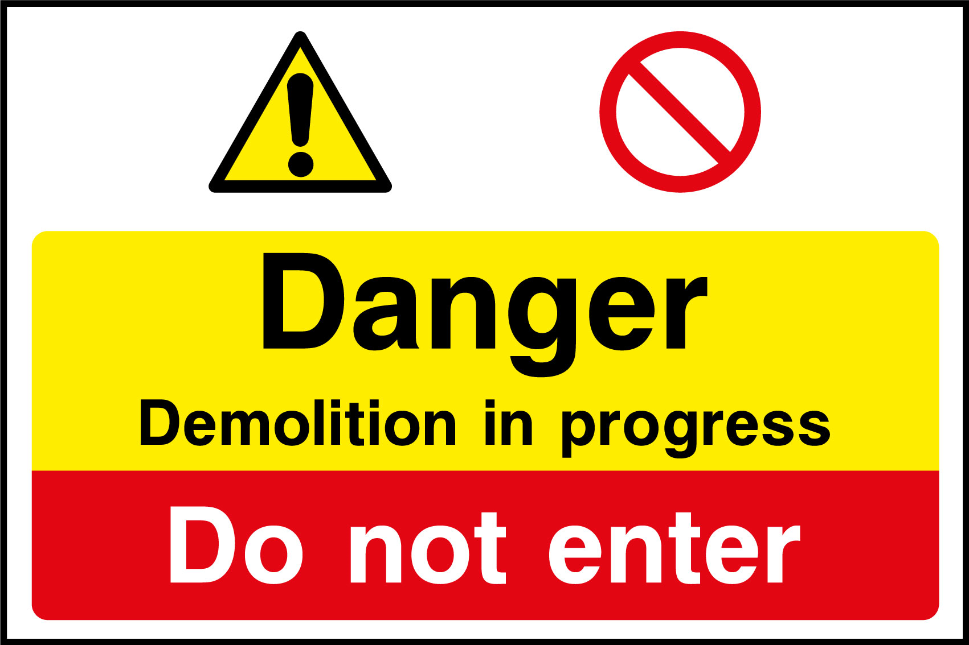

Applying for free school meals

Have you recently become eligible for universal credit due to changing employment circumstances? This may mean that your child/children are also eligible for free school meals. When you apply for universal credit at www.gov.uk/universal-credit remember to check whether this includes eligibility for free school meals. If your children are entitled to free school meals, let us know by text or email. The government have just introduced a system of free school meal vouchers for parents to spend in supermarkets while schools are closed. As soon as we know your children are eligible, we can organise these vouchers.

What do you think of our updated vision and mission statement?

Mr. Pugh has updated our vision and mission statement in consultation with the governors. He is now interested to know what parents think. Check the vision and mission statement 28/05/20 on the blog then share your feedback by completing the parent survey. Mr. Pugh will also be asking Class 4 for their feedback.
THANK YOU!

