WELCOME BACK LEARNERS OF THE WEEK!

Home Learners
Class 1 | Scarlett Gonter
Class 2 | Percy Langman
Class 3 | Freddie Hill | Katrina Wilkinson
Class 4 | Oscar Langman | Steven Rawcliffe
School Learners
Bubble 1 | Olivia Andrew |  | Louie Taylor
Bubble 2 | Lily Smith |  | Szymon Rafalski
Bubble 3 | Beth Shanks |  | Cole Evans

This week’s update
Children’s reports for this academic year have been emailed directly to parents.

You will receive a copy of your child's data collection sheet in the post.
It is essential that you check all the information on the data collection sheet is accurate, particularly phone and email contact details as well as any dietary and health information. Children with health issues may require an individual risk assessment before their return to school, therefore up-to-date health information is essential, particularly in regard to covid-19.
When you have checked the data collection sheet, please sign and date it then either drop it off at school, post it or scan and email to bursar@archbishophuttons.lancs.sch.uk by FRIDAY 17th JULY.
In this way, Mrs. Robinson can make sure that every child's details are correct ready for the full return to school in September.

Today’s blog contains a link to the DfE's guidance
'What parents and carers need to know about early years providers, schools and colleges in the autumn term.'

Mr. Pugh and I are currently updating the school risk assessment following recent government guidance about the full return of all pupils in September.
The risk assessment will be available to parents on the school website by Friday 17th July. Mr. Pugh will then contact parents during the second half of August to confirm arrangements for September.

Zoom Chats
Well done to all those children who joined Miss. Massaro, Mrs. Gavriluk and
Mr. McGurk for this week’s special Transition Zoom Chats.
Mrs. Barclay and Mrs. McKinley are looking forward to their Class 1 transition zoom chat with on Mon 13th July 10.00am.
Meanwhile, Zoom Chats for children learning at home continue. Parents can find the Zoom Chat information on a page called ‘Home School Zoom Chats’ in class pages on the school website. Next week’s Zoom Chat timetable is now available along with the Transition Zoom Chats information for next year’s Class 1 parents.
These zoom chats are very much focused on children. When parents want to contact the teacher they should do so by emailing them.
The teachers' email addresses are:
mrsbarclay@archbishophuttons.lancs.sch.uk
mrmcgurk@archbishophuttons.lancs.sch.uk
mrsgavriluk@archbishophuttons.lancs.sch.uk
mrpugh@archbishophuttons.lancs.sch.uk

Following competition success at Crufts in March, Jenna and her dog, Puzzle, have been invited to the pre selection qualification day for the Young Kennel Club Agility Team GB.
What a fantastic opportunity – good luck Jenna and Puzzle!

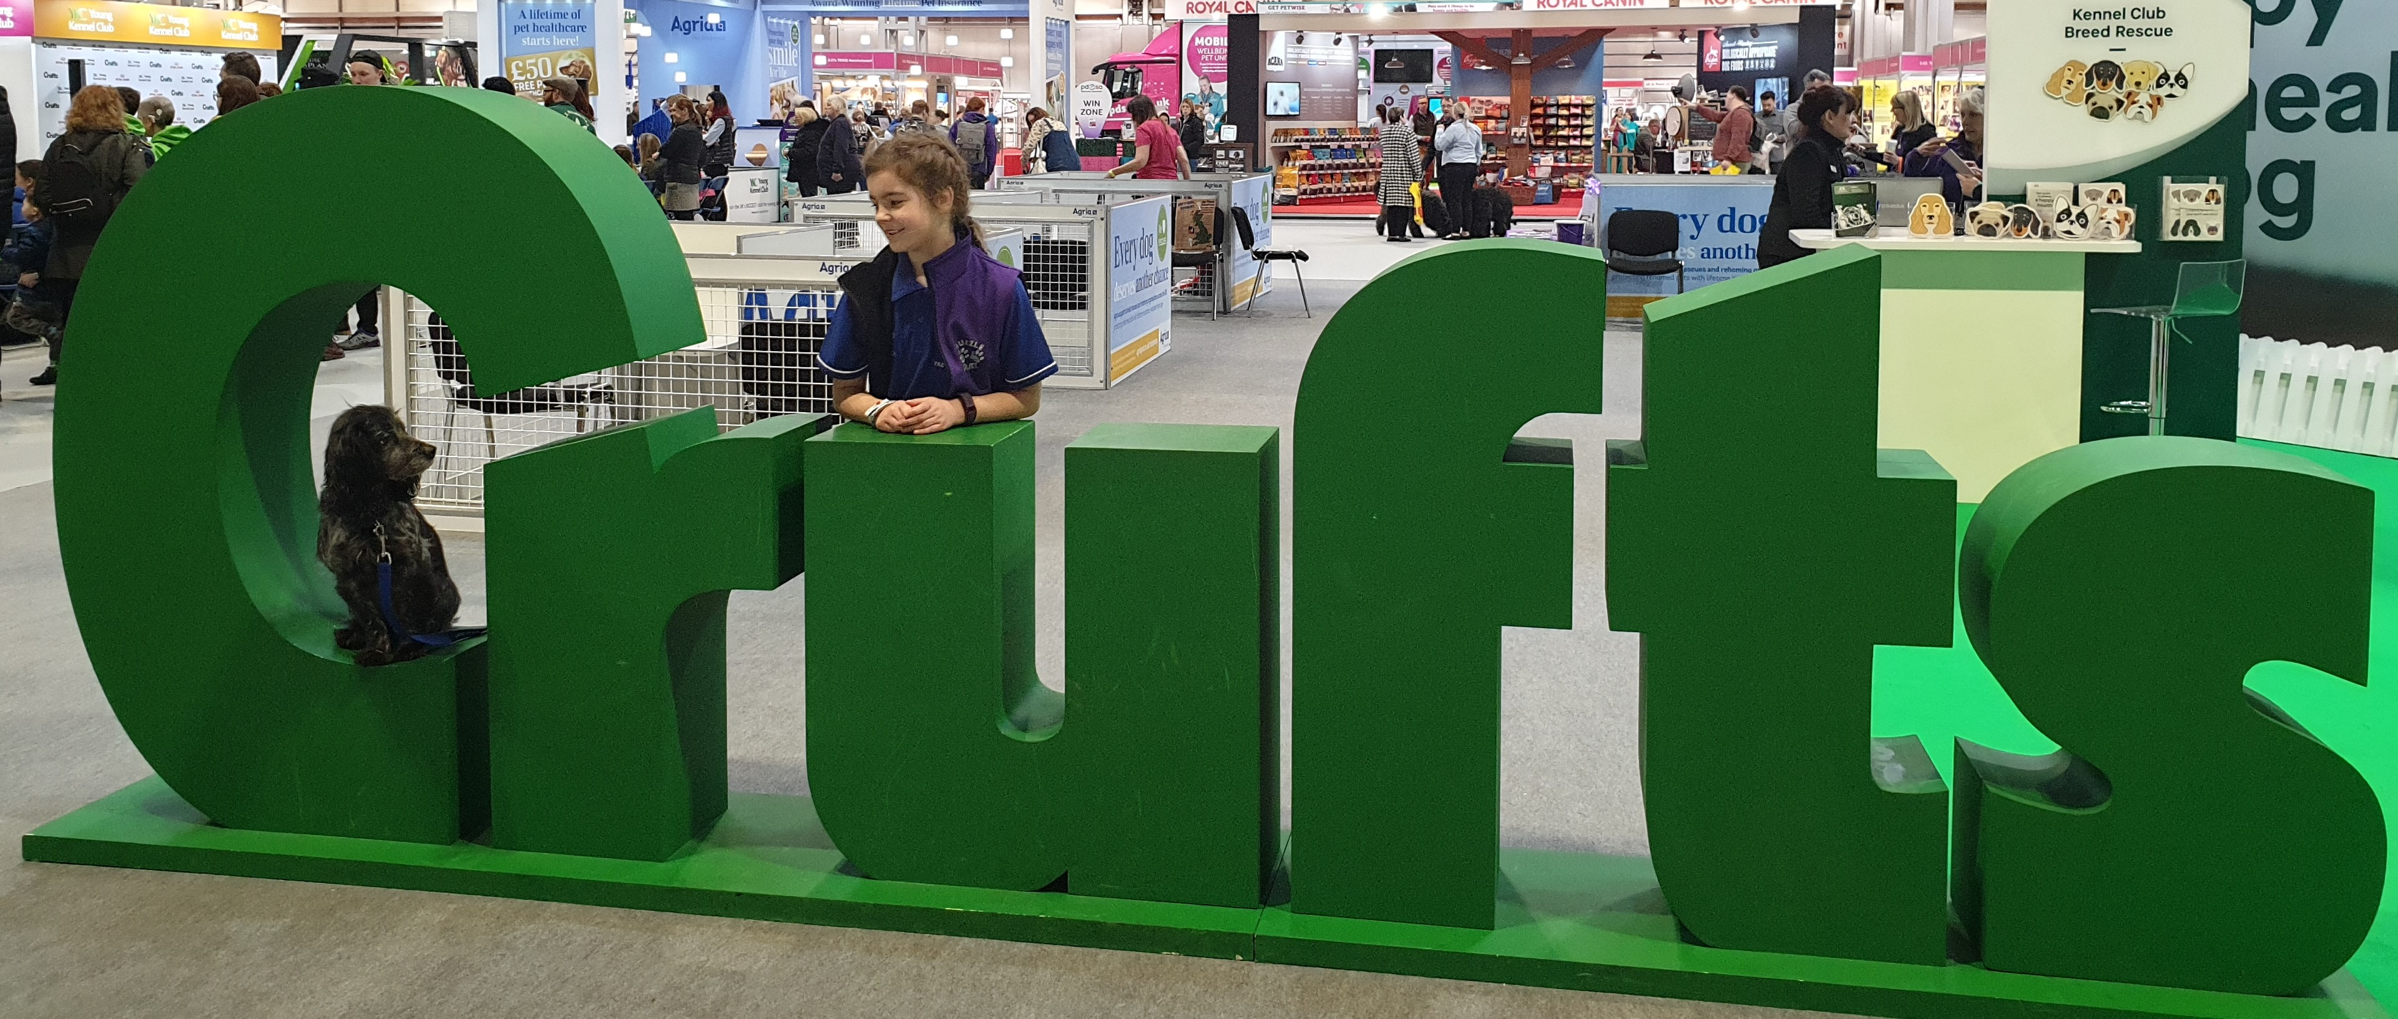

 | Listen to this….  the ABH PODCAST no. 4  Enjoy listening and let us know what you think of it!  Access from the school blog

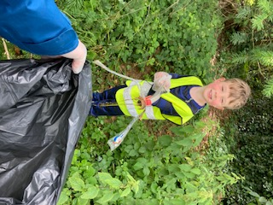 | 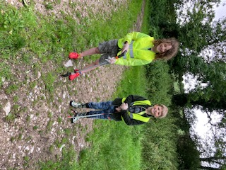
Local ECO GANG keep Warton tidy!
The local Ecogang completed a litter pick last weekend. This was a great success - the group covered 3 residential areas and a public footpath to Senset well.
The ECO GANG used the school’s litter pickers to complete their clean up. They are holding on to the litter picks during the summer holidays as they would like to organise at least two further ones on the Crag and Yealand Woods.
Well done ECO GANG!
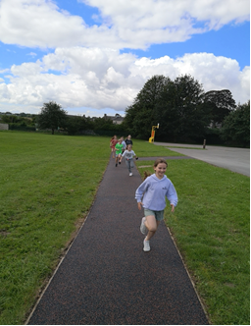 |  | The track is now being used with much positive feedback from the children. They think it looks very smart and feels a bit springy when you run on it.
Keeping in touch  All contact is now via email and alerts on the School Spider app.  The weekly newsletter is published on Fridays. Regular blogs provide additional information and updates when necessary. You will receive alerts when these are available.  Emails will be checked daily during the week.  Next week the school office will be manned on Monday, Wednesday and Friday. |  | 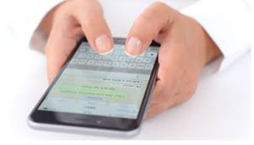

UNIFORM REMINDER FOR SEPTEMBER

From September 2020, school uniform will only include sweatshirts and P.E. tops with the tree logo.
These can be bought directly or online from The Uniform & Leisurewear Company along with book bags and P.E. bags.
Uniform can be purchased at The Uniform & Leisurewear Company shops in Lancaster or Morecambe – these are now open - and online. Orders placed online can be delivered to school free of charge for you to collect.
Here is the website link:-
http://www.ualonline.com/product-category/schoolwear/lancaster/archbishop-huttons-primary-school/
The Uniform & Leisurewear Company  shop in Lancaster | The Uniform & Leisurewear Company  shop in Morecambe
15 Common Garden Street  Lancaster  LA1 1XD  Open Monday to Saturday  From 9.30a.m. to 5p.m.  Closed Sunday and Bank Holidays | 60 Euston Road  Morecambe  LA4 5DG  Open Monday, Tuesday, Thursday, Friday & Saturday  From 9.30a.m. to 4.30p.m.  Closed Wednesday, Sunday and Bank Holidays
Both shops can be contacted on 01524 388355
Find out more on www.ualonline.com

Applying for free school meals

Have you recently become eligible for universal credit
due to changing employment circumstances?
This may mean that your child/children are also eligible for free school meals. When you apply for universal credit at www.gov.uk/universal-credit remember to check whether this includes eligibility for free school meals.
If your children are entitled to free school meals, let us know by email or phone. The government have just introduced a system of free school meal vouchers for parents to spend in supermarkets while schools are closed.
As soon as we know your children are eligible, we can organise these vouchers.

School closes at 3.10pm
on Friday 17th July
and re-opens at 8.45am
on Thursday 3rd September

