THIS ACADEMIC YEAR’S FINAL LEARNERS OF THE WEEK!

School Learners
Bubble 1 | Baylee Jackson | Amelie Fairclough
Bubble 2 | Charlie Andrew | Katie Denney
Bubble 3 | Summer Denney | Joseph Henderson

YEAR 6 – THE CLASS Of 2020

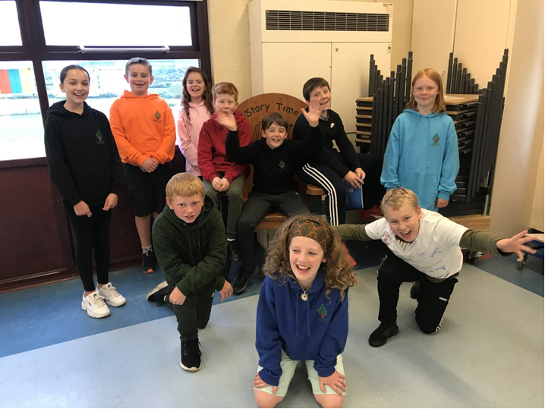

YEAR 6 MEET UP  It was great meeting  Year 6 on Wednesday afternoon for lunch with  Miss. Watson &  Mr. Pugh. While this was far from our normal end of Year 6 experience, some traditions were maintained! Year 6 completed the usual shirt signing, checked out the new track, received their 2020 Year Book and said goodbye to the staff who were in the building. | 
 | GOODBYE YEAR 6!  All the staff would like to wish Year 6 the very best for starting their high school lives in September as well as much success for whatever the future holds, both at high school and beyond!

MISS WATSON’S FINAL FAREWELL

I have worked as Headteacher at Archbishop Hutton’s for 3½ years during which time the school has changed in to the caring, proactive and vibrant learning community it is today.
I am incredibly proud of ALL the children – I love their enthusiasm, curiosity, good manners, creativity and engagement with learning.
I have really enjoyed establishing positive relationships with parents, listening to and acting on your feedback, providing support when necessary and involving you in appreciating the fantastic learners your children are.
I am very appreciative of the strong, talented team of staff, both those who work in classrooms and those whose roles support beyond the classroom. This is a team who pull together in times of crisis, who are open to change and keen to learn – who want to be the best they can be in order to support the children in achieving the same.
The governing body is the best I have ever worked with – this dedicated group of people bring their individual skills to support and improve the school whether that relates to building development, improving computer hardware, fundraising, curriculum expertise, local knowledge, problem solving, even demolishing a barn!
Archbishop Hutton’s is a real school community of adults who work together in the best interests of the children they support.
It has been a genuine privilege to lead this brilliant school!
When people ask me why I am leaving my usual answer is – if Archbishop Hutton’s could be nearer where I live and have double the number of pupils I would stay, however that’s impossible so I am moving on to a lead a bigger school in Colne that is much nearer home. However, I believe this is a real gem of a school that has all the magic ingredients to continue on its improvement journey.
I know that Mr. Pugh will continue leading the school on its improvement journey from September.
I look forward to returning at some point next academic year to admire all that YOU will have achieved.
THANK YOU for all your support, the thoughtful messages and lovely gifts.
Wishing you all much happiness, good health and success for the future!

Sarah Watson

 | Listen to this….  the ABH PODCAST no. 5  Enjoy listening and let us know what you think of it!  Access from the school blog

UPDATE re: RISK ASSESSMENT FOR SEPTEMBER
Mr. Pugh and I have discussed the risk assessment for September with the Health & Safety Consultant we are working with. We are waiting to receive the final copy of this. Unfortunately, the Health & Safety Consultant has been unable to provide this by today due to unforeseen circumstances. Either Mr. Pugh or I will publish the risk assessment on a website blog as soon as it becomes available.
Mr. Pugh will then be in contact with parents/carers in mid-August to confirm arrangements for all children returning to school September.

Keeping in touch  All contact is now via email and alerts on the School Spider app.  The best way to make contact during the summer holidays is by emailing bursar@archbishophuttons.lancs.sch.uk  Emails will be checked at various points during the holidays although not daily so please patient if awaiting a response. | 

UNIFORM REMINDER FOR SEPTEMBER

From September 2020, school uniform will only include sweatshirts and P.E. tops with the tree logo.
These can be bought directly or online from The Uniform & Leisurewear Company along with book bags and P.E. bags.
Uniform can be purchased at The Uniform & Leisurewear Company shops in Lancaster or Morecambe – these are now open - and online. Orders placed online can be delivered to school free of charge for you to collect.
Here is the website link:-
http://www.ualonline.com/product-category/schoolwear/lancaster/archbishop-huttons-primary-school/

The Uniform & Leisurewear Company  shop in Lancaster | The Uniform & Leisurewear Company  shop in Morecambe
15 Common Garden Street  Lancaster  LA1 1XD  Open Monday to Saturday  From 9.30a.m. to 5p.m.  Closed Sunday and Bank Holidays | 60 Euston Road  Morecambe  LA4 5DG  Open Monday, Tuesday, Thursday, Friday & Saturday  From 9.30a.m. to 4.30p.m.  Closed Wednesday, Sunday and Bank Holidays
Both shops can be contacted on 01524 388355
Find out more on www.ualonline.com

Lancaster City Council - advice and support

As the Summer Holidays approach we felt it was an appropriate time to remind you of the sort of support we can offer over the holiday period and beyond.

We are aware that some families will be receiving food vouchers under free school meals https://www.lancashire.gov.uk/children-education-families/schools/free-school-meals/ . We also want families to be aware of the support on offer from the Council and that we can refer families (or individuals) to a network of volunteers to help with things such as collecting shopping, medicines and telephone befriending services. We are also on hand to help advise on things such as benefits, waste collection and other council services.

Details of how to get this help are below.

Lancaster City Council has set up a 7-day telephone and email help line to make sure people can get reliable support:
- by phone 01524 582000
- by email customerservices@lancaster.gov.uk (for residents)
- or email econdev@lancaster.gov.uk (for businesses)

The phone lines are open Monday to Friday from 8am to 6pm and every Saturday and Sunday between 10am and 3pm. The hours are being kept under review and we may amend them in the future.

The council has also been working in partnership with Morecambe Bay Foodbank to co-ordinate and deliver emergency food parcels to vulnerable people across the district and they are available to anyone who is struggling during these unprecedented times and because the circumstances people may now find themselves in are unprecedented, I would urge you, to communicate widely, that there is no shame or loss of dignity in accessing the support, we are seeing many families coming forward who under normal circumstances manage very well and are trying to reach out to as many households as possible.

A new website, www.lancasterdistrictcovid19.org.uk, has been created for agencies to refer someone for emergency food. If anyone needs help, they can find the contact details of people and organisations who can refer them or they can phone the councils community hub on 01524 582000.

In addition to the regular Community Offers Bulletin that we are sending out, Lancaster City Council have a dedicated website (link below) where people can find out how to get emergency food, business grants, business rate relief and advice and guidance. http://www.lancaster.gov.uk/sites/coronavirus-information

The following link lists support for individuals and families http://www.lancaster.gov.uk/sites/coronavirus-information/help-for-individuals
We are aware that a lot of people are struggling financially at this time. If anyone needs help managing debts, or needs help putting together a budgeting statement then the Citizens Advice Bureau have trained debt advisors that can help, they can also check to make sure people are receiving the correct level of benefits. To book a telephone appointment email enquiries@northlancashirecab.org.uk or phone: 03444 889 622 (9am - 4pm, Monday - Friday)
Council tenants who are struggling to pay their rent can contact our Income Management Team who are here to help. Their telephone number is 01524 582541 or they can be contacted via email IncomeManagementTeam-CH@lancaster.gov.uk
Private Tenants who need advice with any landlord / tenant issues can contact the council on 01524 582257
A small number of places are available on a summer play scheme, contact details below for enquiries

Monday to Friday from 20th July to 14th August 2020
Ages 8-11
Time ‪10am to 4pm (9:30am to 3:30pm Our Lady’s Catholic College Lancaster)
Cost £3 per day
Tel: 07483 335 066
Email: ceep@ceep.org.uk

Applying for free school meals

Have you recently become eligible for universal credit
due to changing employment circumstances?
This may mean that your child/children are also eligible for free school meals. When you apply for universal credit at www.gov.uk/universal-credit remember to check whether this includes eligibility for free school meals.
If your children are entitled to free school meals, let us know by email or phone. The government have just introduced a system of free school meal vouchers for parents to spend in supermarkets while schools are closed.
As soon as we know your children are eligible, we can organise these vouchers.

School closed TODAY
and re-opens at 8.45am
on Thursday 3rd September

While life is still a bit strange and not quite normal, the staff wish all our families a very happy, healthy and safe summer holiday!


